AutoCams 2 — Installation and Procedures

Goals
Install and run the single-camera CAMS system

Tasks | 1. | Set up the Camera
 | 2. | Clock Synchronization
 | 3. | Introduction to the AutoCams and Cams Programs
 | 4. | Daily Workflow
 | 5. | Directory Structures
 | 6. | Download and configure the CAMS software
 | 7. | Calibrate FOV (Manual Calibration)
 | 8. | Manual Re-Calibration Sample Run
 | 9. | Setting up the Task Scheduler
 | 10. | Summary
 | 11. | Calibrating
 | 12. | Applying Calibration to Detect File
 | 13. | Confirming (optional)
 | 14. | Transmitting
 | 15. | Archiving
 | 16. | Calibration Tricks
 | 17. | Coincidence
 | 18. | Archiving for DVD with Pre-DVD Archive utility
 | 19. | “AutoCams.Params.ini” file settings
 | 20. | Focusing Tips and Tricks
 | 21. | Calibration tricks
 | 22. | Force AutoCams2 to retry upload of submission
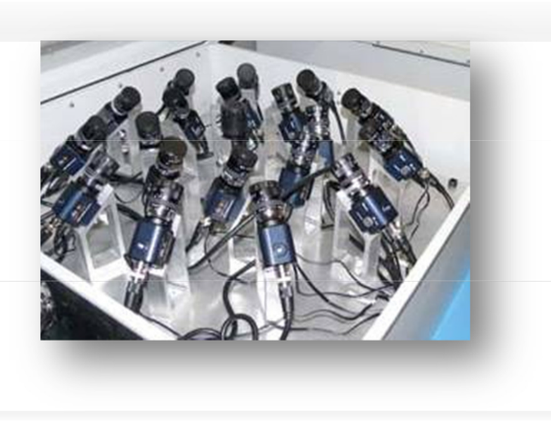
Background
This document describes the amateur CAMS system that you can install at your home, school, or other location. CAMS is an acronym for "Cameras for All-sky Meteor Surveillance". The first three main all-sky CAMS array sites were set up in the Northern California network at Fremont Peak Observatory, Lick Observatory, and Sunnyvale. There is also a version that captures spectral data.
For complete installation steps of the software and scripts, use:
http://davesamuels.com/cams/camsupdates/documentation/Installing a new CAMS system.pdf
For other documentation related to CAMS, they are available at:
http://davesamuels.com/cams/camsupdates/documentation
NASA/SETI is allowing amateurs to contribute to this science by setting up single- or multi-camera CAMS systems at their homes, schools, etc. and this will provide a level of redundancy against fog and other breakdowns as well as
providing improved accuracy in the data. You may be credited for discoveries and measurements made by your CAMS site. For additional information, see "http://cams.seti.org/easyCAMS.html". There is a user support group on Yahoo Groups that you can join by emailing:
"seticams-subscribe@yahoogroups.com". Once you subscribe, please enter your site information into the "CAMS Locator Table" Database and use the Database to find others in your local network.
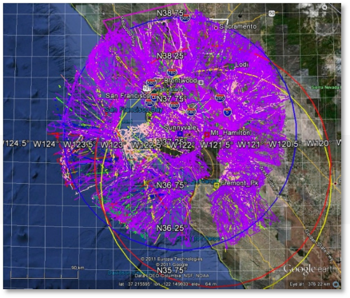
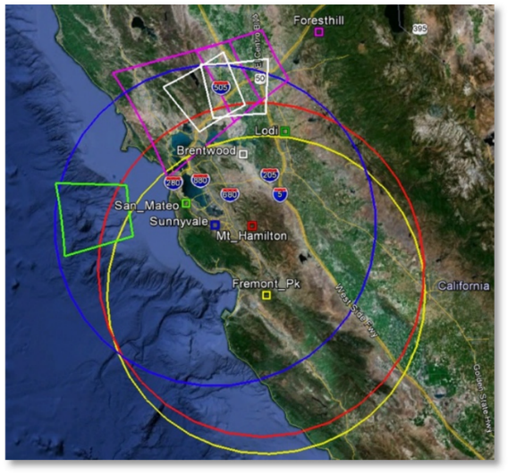
The picture on the left shows the areas of coverage of the CAMS arrays in the San Francisco bay area and its single CAMS sites (circa 2012). The next picture shows the meteor tracks from the Mountain View, CA CAMS array on a single night in Dec 9, 2011, even with some cameras not functioning. You can see that Earth is under constant bombardment.

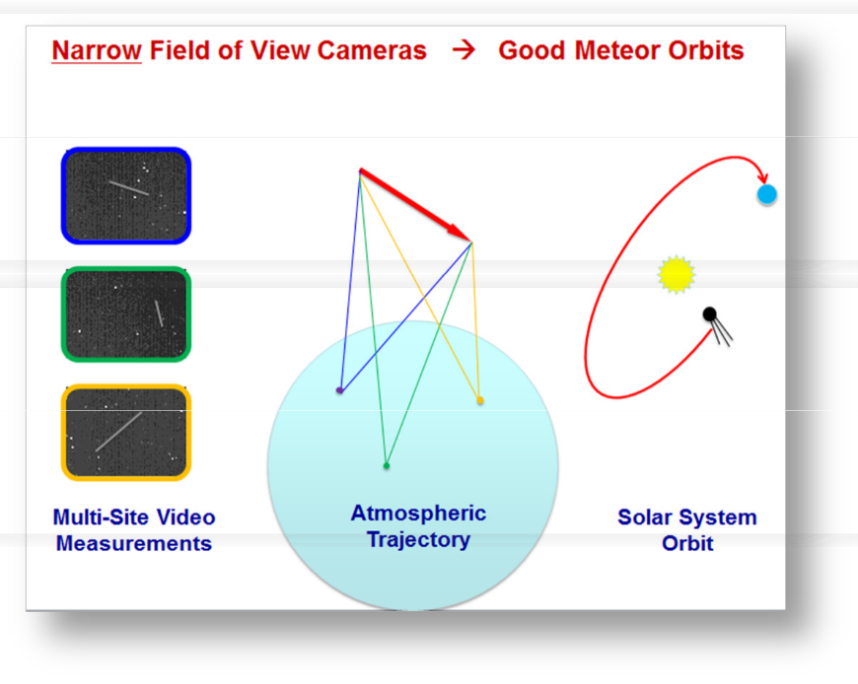
In 2011, there were over 400 or more known meteor showers. 300 of those were not confirmed. The purpose of the NASA/SETI CAMS project is to confirm the known meteor showers and discover new ones. You can visit "https://www.ta3.sk/IAUC22DB/MDC20 07/" or just Google search "Meteor Data Center"
A meteor shower is caused when the Earth passes through the dust trail of a comet or asteroid that has previously passed through Earth's orbital path without colliding with the comet. A meteor shower implies the presence of a potentially hazardous comet. If the dust trail can hit the Earth, so could its parent
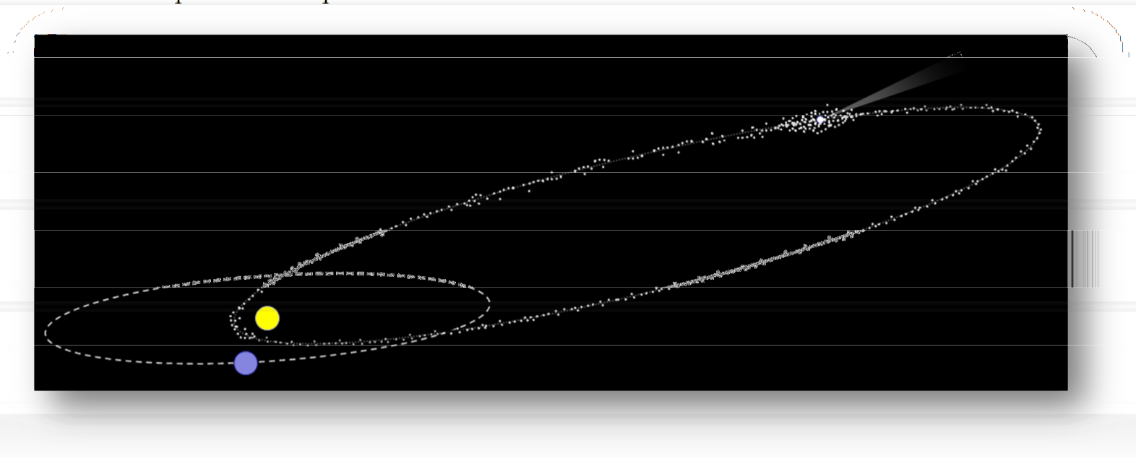
comet. The dust trail shares the same orbital path as its comet. In principle, it will be possible to guard against such impacts by looking along the meteoroid particle stream orbit to those spots where the comet would be in such a dangerous position - possibly providing a few years of warning. There is no real need to find all the comets associated with all the meteor showers, only those comets that would be in the position to impact Earth need to be located.

Using the CAMS array, since November, 2010, hundreds of meteor showers have already been detected and new ones have been discovered (See http://cams.seti.org for updates). Over 50,000 orbits were calculated in the first year of operation! In 2019 there were over 619 cameras worldwide in 116 sites in 23 networks. Almost 360,000 orbits calculated in just 2019 alone. See IAU’s Meteor Data Center for lists of showers. This image shows the growth since 2007 of the meteors detected per year. The black and blue lines depict CAMS orbits.

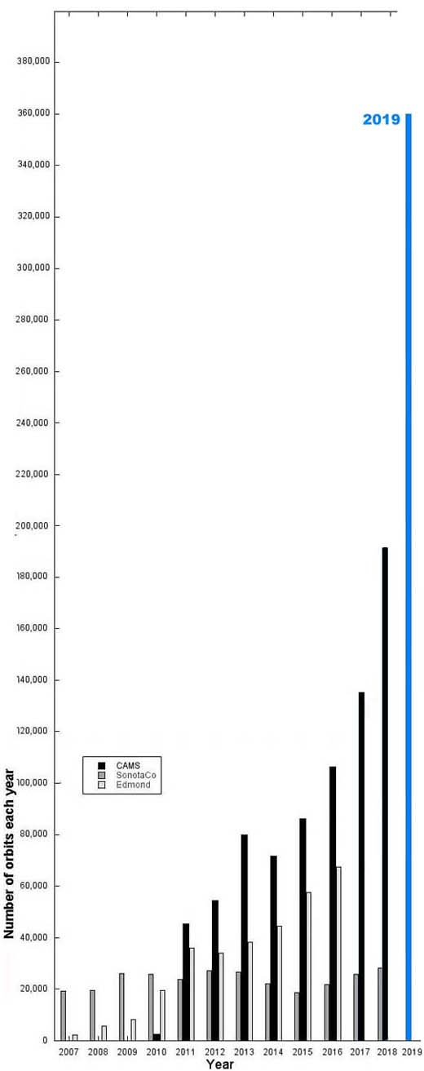

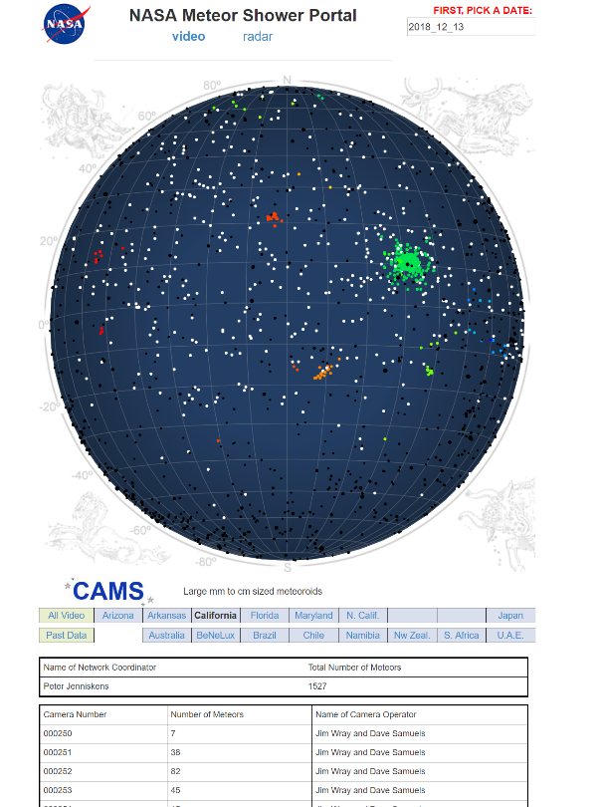
For an updated interactive view of meteors, see the FDL site (http://cams.seti.org/FDL/index.html). You can see in this screenshot where it shows a map of the night sky with several meteor showers (colored dots) detected by CAMS, along with the cameras, count, and their site operators contributing to the coincidence/triangulations.
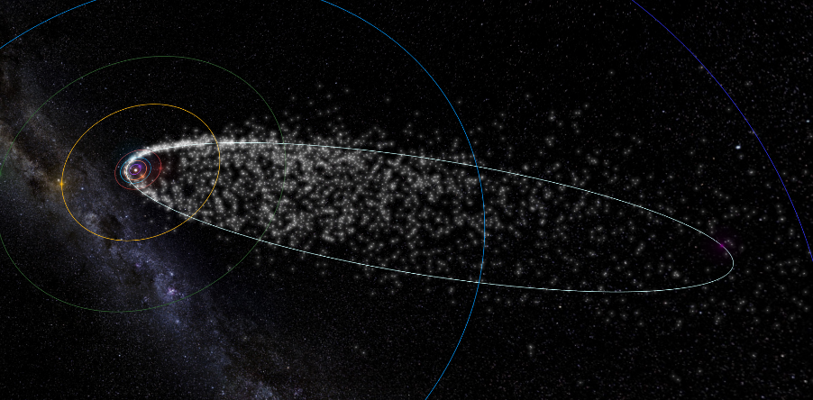
Clicking on a dot presents an animated depiction of the meteor shower’s orbit.

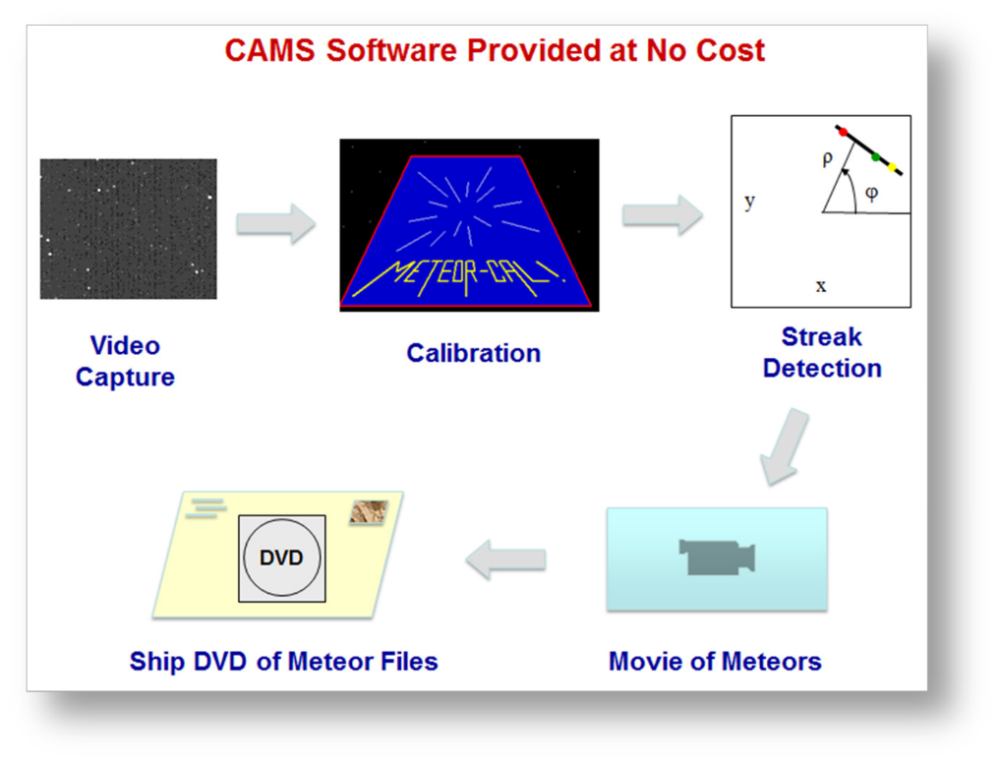
A CAMS system takes movies from a highly sensitive video camera at 30 fps and searches for signs of meteors in the video frames. This detection is done locally using software that is provided at no cost, in order to reduce the volume of files sent back to NASA/SETI. Data, in the form of small text files, is sent back to a central coordinator at NASA/SETI where triangulation (coincidence) from other sites is performed to ascertain additional information, such as speed, angle of attack, altitude, and finally the orbital elements of the particles. Only two
cameras need to capture the same meteor to determine the orbital elements of the particle stream. The more cameras that can detect the same meteor, the more accurate the orbital data becomes - as well as providing a higher meteor count for all overlapping stations. Also, the more sky coverage, the more likely it is to detect a meteor in another part of the sky belonging to the same particle stream.

SINGLE-CAMS PRINCIPLES
With all the things that could go wrong with an amateur operated single-CAMS station, it was apparent from the start that these three principles of single-CAMS should be adopted:
1. Capture is the first priority. No matter what, capture.
2. Don’t send bad data to NASA.
3. Don’t make it so that data needs to be resent.
Capturing is indeed the single-most important function. If you capture but don’t do the other stuff right away, you can always do it later. But if you don’t capture, then you’ll never be able to re-create what you’ve missed. If you are triangulating with another site, then if you don’t capture, it makes the work that the other site is doing useless. There have been numerous times when it was raining or cloudy in the evening (but captured anyway), to find out that it cleared up not too much later and the station was able to contribute valuable data that night. In some cases, a fireball would be captured through a hole in the clouds. Originally, I had my camera set up on a tripod under my back patio. Eventually, I purchased a set of security camera enclosures so that I’d have more flexibility as to the pointing. Enabling the camera only when you believe that it is good enough clear sky works against this first principle and the data proves that point. Automation is the way to achieve the goals of this principle.

HARDWARE
Before you begin, you will need the following items:
- Required:
  - Video Capture device - The following devices have been tested:
    - Sensoray Model 812 8-channel frame grabber ($216 or $202 in qty 2+). This is the workhorse of the CAMS system worldwide. These are full-size PCIe boards and sometimes they don’t fit in small form factor systems.
    - EasyCap 116 USB ($31) We suggest purchasing and extra one to use as a backup - it is a critical path and it can fail.
    - Other video capture devices have been used. Some produce very poor images and some are unreliable. The recommendation is to check with us before purchasing to determine if your device has been vetted and proven to work with CAMS.
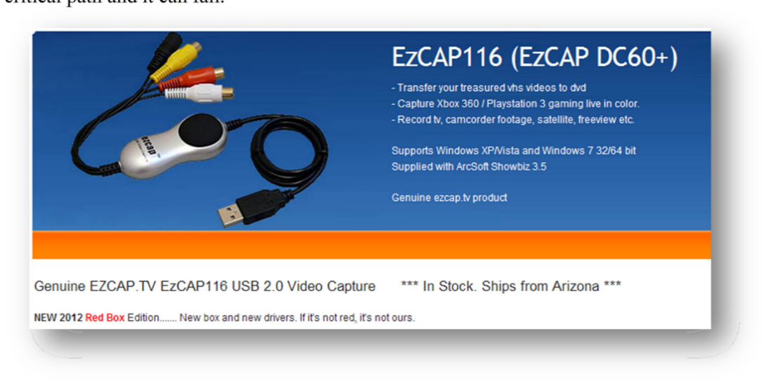

Warning: According to "http://www.easycap.tv/", the original EasyCAP device has been pirated and is not the fake one available on the amazon.com link below. The one at the Amazon.com link below is the one that I use and it works. I have tested that device on Windows 7 64, and it does work on XP and Windows 2003 64. It is difficult to determine who is telling the truth. Some have stated that the devices with the gold contacts is the original, where the devices without the gold contacts is the fake.
Note: The older version of EasyCap DC60 is about $8 and has proven to drop video frames and data. While it will work in some cases, it is better to get the "plus" version. However, the 116 is the official non-pirated product.
•
    - http://www.ebay.com/itm/EzCAP-116-easycap-DC60-XP-Vista-Windows-7-/200623434994

    - http://www.amazon.com/Easycap-Version-Capturer-Camcorder- Compatible/dp/B0044XIQIW/ref=sr_1_1?s=electronics&ie=UTF8&qid=1338269556&sr=1-1

  - CAMERA – There are several cameras to choose from. Ideally, a Watec 902 H2 Ultimate is used. However, these are over $400. There are pros and cons for these though. They are good and reliable and produce good images for years. However, for the price of one camera and the more expensive ½ inch lens, you could purchase 10 of the cheaper 1/3” cameras each with a f/1.0 lens.
    - Watec WAT-902H2 Ultimate (about $400)
      - http://www.spytown.com/watec-wat-902h2-ultimate-eia.html ($308)
      - http://www.avsupply.com/Watec/wat-902h2-ultimate.php
      - Watec WAT-AD901 1210 (about $29) - Sometimes, the 12 VDC power supply does not ship with the camera. You may need to purchase one. You may be able to scrounge one up from an old 12VDC adapter laying around like I did. Just be sure that the connection is the correct polarity before plugging it into the camera. If you are not in the US, you may need a different power supply.
      - http://www.spytown.com/watec-wat-ad901-1210.html ($29)
      - http://www.amazon.com/Watec-WAT-AD901-220VDC-300DH- 525EX/dp/B006WXR6X8/ref=sr_1_1?ie=UTF8&qid=1339544094&sr=8-1 ($29 no tax, no shipping)
    - Sony ExView HAD II 960H based 1/3” camera. (between $13 and $70) Contact us before purchasing. Various cameras have been successfully purchased from various Chinese vendors. Be sure to ask the vendor to remove the IR cut filter before ordering. You may need to remove the IR cut filter yourself with a heat gun.
Important: You do NOT need the “astronomy” version of these cameras.

  - LENSES – It’s important to purchase the correct lens for your camera.
For the ½” cameras, the 12mm f/1.2 Pentax lens (or comparable) is used. Better focal ratios are not readily available and they are very expensive. But if you can find a good one that is f/1.0 or brighter, by all means get one, and test it, and let the rest of us know.
For Watec:
    - For Watec only: 12-mm f1.2 Pentax lens (about $110) or 8mm f/1.2 Pentax lens for zenith camera.
      - http://www.spytown.com/pentax-c61215kp.html
      - http://www.nextag.com/Pentax-C61215KP-12MM-F1-616003011/prices-html
      - (also at AV supply)
    - C-CS mount adapter (about $16. You most likely need this to reach focus. See the section 1.2. Attach the Pentax 12mm f/1.2 lens below about reaching focus)
      - http://www.bhphotovideo.com/c/product/569849- REG/Pentax_C80035_C80035_C_CS_Mount_Adapter.html

For the 1/3” cameras, there are several vendors offering f/1.0 lenses for $8-$15. These are IR lenses. It is important for the 1/3” cameras that the focal length of the lens is purchased based on the elevation angle of the pointing of the camera (to maintain the target spatial resolution at the 90 km atmosphere layer).
6mm for cameras pointing 74 – 90 degrees.
8mm for cameras pointing 45 – 74 degrees.
12mm for cameras pointing lower than 45 degrees.
You can practically make an all sky array with sixteen 1/3” cameras using these
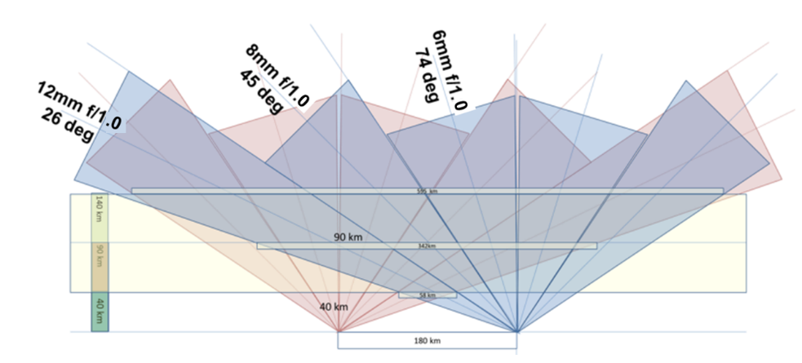 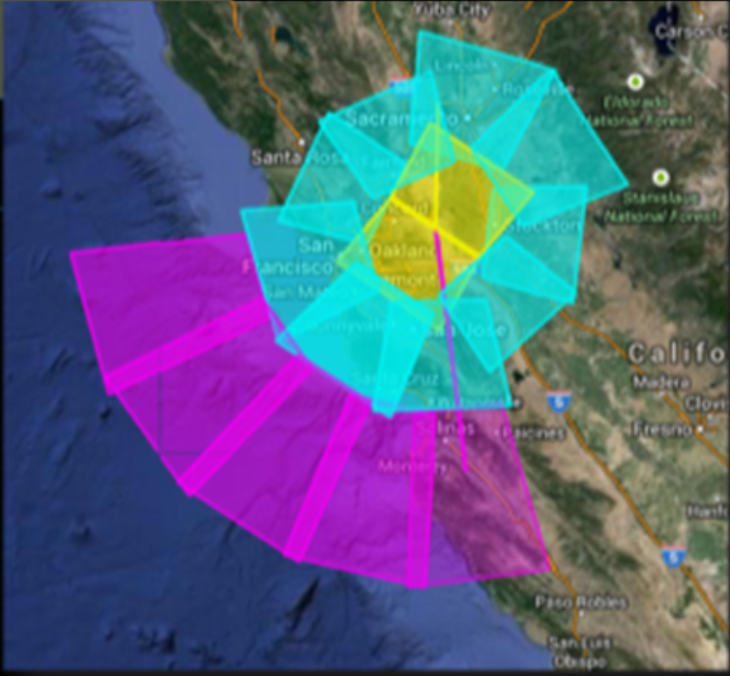
    - Video cable for outdoor: We have learned that the best approach is to use Cat 5 or Cat 6 internet cable with video baluns at each end. Using coax cable, such as RG6 is prone to excessively noisy images. If you have coax, you can purchase ground-loop baluns to reduce the noise. Some say that RG6 (cable tv) cable is best for long distances. Would require F-type screw-on adapters for the bayonet and RCA male ends. However, using Cat 5 or Cat 6 cable with video baluns at each end reduces ground-loop noise and other interference and Cat 6 ethernet cable should be able to be run hundreds of feet.
      - Ethernet cable, 100 ft, Cat 6:
A search on Amazon for 100 ft cat6 cable turns up at $25 today (2021).
Ethernet Cable, 100 ft, Cat 6 - Amazon
      - Video Balun:
Here is an example of inexpensive 4 port video balun. You need one at each end for four cameras on a single Cat 6 cable. Cantek CT-W-VB804M or Cantek CT-W-VB204 $12. However, you might also want to use one with POe (power over ethernet) ability, which would cost more.
Important note: We have recently learned that using coax cables without ground-loop isolator baluns opens each camera up to numerous potential video problems. Below is an example of Before/After images of a security camera with such issues:
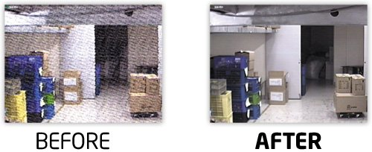
If your system is already using COAX between the cameras and the computer, it is a good idea to install one of these at one end of each video cable if you have double-stars, ghosting, vertical or horizontal noise moving across the screen, etc.
These devices only need one device at one end. You can find them on Amazon for under $10 each.
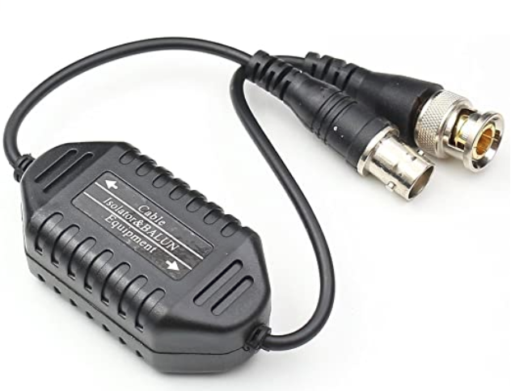
If you are using ethernet cables for your video cables, you probably already have Cat5 or Cat6 cables with “video baluns” at each end. With this approach, you can run 4 camera feeds through a 4-port passive video balun with a passive video balun at each end. Using video baluns like this should avoid ground-loop interference problems the same as the ground loop isolator baluns. (I haven’t tried using both).
These devices can be found on Amazon for under $15 for each end.
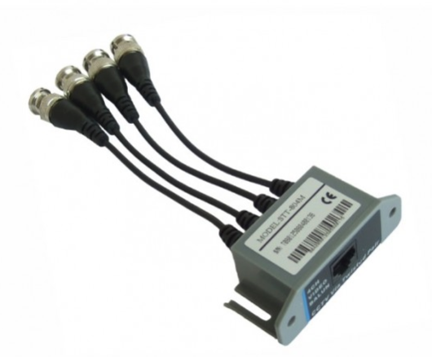 or 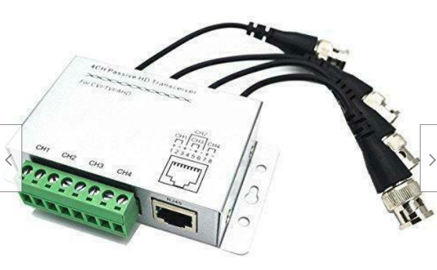
For more before/after of noise, see this link:
Noise Examples

  - Camera housing $25
    - http://www.surveillance-video.com/sa-605.html
    - If you are going to mount the camera to a building or structure,
    - http://www.spytown.com/everfocus-fhb-300hb.html $35 with Heater/Blower
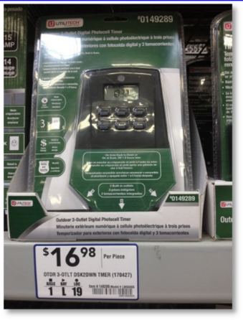
    - Spytown shipping is too high.
Additional equipment:
    - Extension cords ($10)
    - Wall timer ($15-$20) (I found that the electronic model is more reliable and doesn't lose time during power outages)
You should really use one that has a day/nite photo-electric mode but you have to be sure not to install them where someone could flip a light switch on.
http://www.lowes.com/pd_149289-95325-LW68465_0 0 s%3FNtt%3Dutilitech%2Btimer&facetInfo=
or you can go the traditional route with the inexpensive mechanical Christmas tree timers that need to be constantly checked for accurate time:
http://www.christmaslightsetc.com/p/Outdoor-Timer/Photo-Control-Controllers-/-Timers-/-Light- Testers-/-Faders--20704--107.htm
    - ShockBuster Ground Fault Circuit Interrupter (GCI) portable safety outlet. $13 from Lowes. Part number #30339011.
http://www.lowes.com/ProductDisplay?partNumber=145275-33536-30339011&langId=- 1&storeId=10151&productId=1135923&catalogId=10051&cmRelshp=rel&rel=nofollow&cId=P DIO1
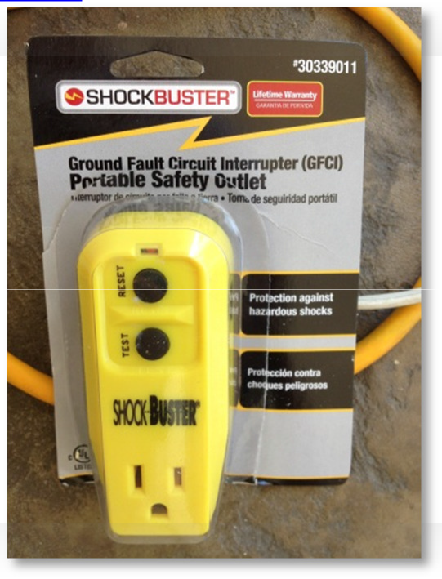
    - Tripod or other mounting system ($10 - $100)
http://www.walmart.com/ip/Sony-39-Lightweight-Camera-and-Camcorder-Tripod-VCT- R100/4948189
A word of caution: While mounting the cameras on the roof works and it seems like a good idea, it might be less than ideal. Climbing on the roof to perform maintenance duties, such as focusing and pointing and lens cleaning can be troublesome. It is inconvenient and it causes wear on the roof. You may be better off mounting the cameras in a location more accessible. An easy method is to simply put a 4 x 4 by 6 ft high post in a location that allows you to point your cameras in any direction. Whatever method you choose, be sure that the location is easily accessible.
    - 2 External hard drives - CAMS is highly data intensive. It is important, in order of priority, to get the storage devices that provide the proper service. CAMS captures about 6 GB per camera per night. We typically like to try to keep at least 30 days of data before culling any of it. We also prefer to implement a 2-Tier or 3-Tier storage management for working storage (Tier 0 or 1), working Archival storage (Tier-2) and permanent offline storage (Tier-3). See the paper “CAMS Storage Management.pdf” for more information. If you’re going to get one of these, either USB 3.0 or 1GigE NAS device is recommended.
      - Another option is a docking bay or docking station. I have aThermaltake Dual Bay Docking Station ($70). This is compatible with 2.5" and 3.5" internal SATA hard drives. The dual bay station allows you to backup from drive to drive. Each drive requires its own eSATA port or USB 3.0 for maximum performance (3,000mbps). They also have a single bay unit for $20 less. With this, you can use cheaper 3.5" drives without having to purchase an enclosure for each.
      - You can get External USB 2.0 or even USB 3.0 external hard drives for under $100 ea. I personally recommend units that are powered by the USB buss. http://www.amazon.com/Western-Digital-Passport-Essential-Portable/dp/B0041OSQ9S

Task 1 - Set up the Camera
This section has a lot of details, but it really is quite simple and only takes a few minutes.
  - Set the camera settings as follows. These instructions are for the WATEC cameras. Similar settings for the Sony based cameras can be attained. Contact us for settings that others have found successful. Also see IMC2014_Paper_ThirdInchCamerasForMeteorSurveillance_Samuels-Wray_Final.pdf.
For Watec 902 H2, follow these steps:
    - BLC = 1 and 2 ON, 3 OFF. This setting sets the backlight to the full chip and not just a portion of it.

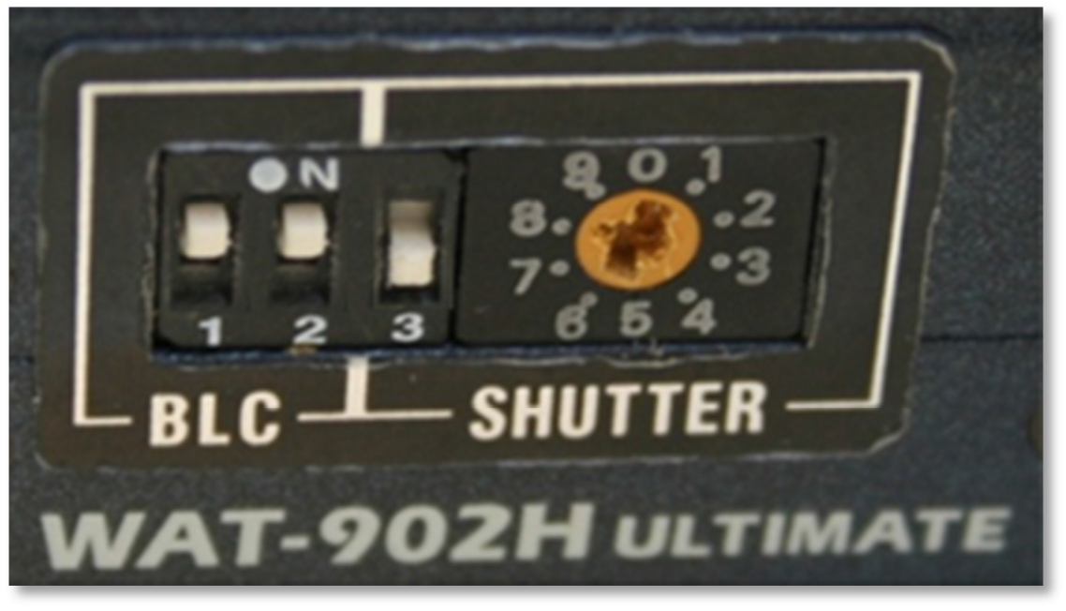
    - SHUTTER speed. Setting switch 3 to off causes the camera to be in 1/60 second shutter speed, which is the same as switch 3 ON and the shutter speed setting to 8.

It is useful to set the shutter speed to 7 and then set the switch 3 to OFF. Essentially, what this does is it sets the shutter speed to 1/60 second for normal CAMS nighttime operation. However, it sets the shutter speed to 1/100,000 sec when it is ON. That way, if you need to do some daytime testing, the 1/100,000 shutter speed is easily accessible and you won't have to fumble around for the manual to figure out what the daytime setting is. Just remember to set switch 3 back to OFF when you're done.

Warning: Don't use a metal screwdriver to change these settings. The best thing to use is a plastic screwdriver. Using a metal screwdriver for these settings can easily damage the main board inside the camera.
    - AGC (automatic gain control) - set to LO or MGC. Some suggest setting to LO. The camera used for these instructions had to be set to MGC (manual gain control) in order to capture enough stars to be able to calibrate. Any AGC setting will skew the photometry, so the best setting is an MGC setting where the gain is at the threshold of producing images as noise free as possible but with as many or more stars than LO produces.
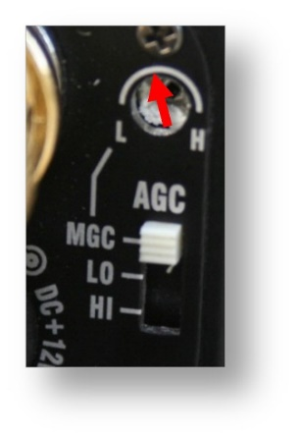
Probably the best advice is to set the AGC to MGC and adjust the L-H gain setting until the image appears to show the same number of stars as the AGC LO setting does. However, I have found that a slight increase in gain over the AGC LO setting produces easier to see meteors during confirmation but the drawback is a slight increase in noise (which increases the number of false positives). The goal is to reach a balance of signal to noise. Too much gain and a clear night with 30 meteors will produce 800+ false-positives. When the gain is set correctly, a clear night with 30 meteors will produce only about 200-270 false-positives.
Having said all that, when you are focusing and pointing, it might be a good idea to temporarily set the AGC setting to HI. Just don’t forget to set it back when you’re done.

Warning: If you're going to use the MGC settings, don't use a metal screwdriver to change these settings. The best thing to use is a plastic screwdriver. Using a metal screwdriver for these settings can easily damage the main board inside the camera.
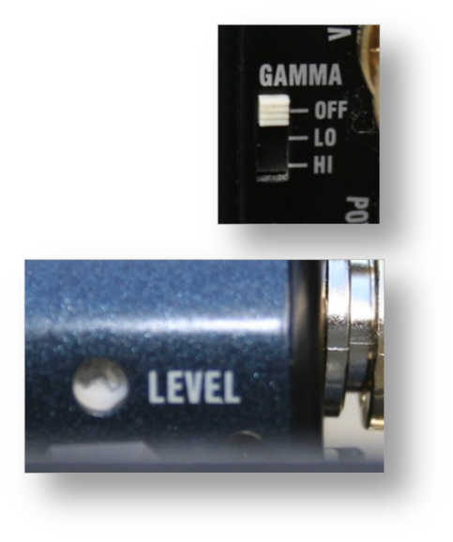
    - GAMMA - Set to off. The higher the gamma setting, the higher the noise. In addition, the higher the gamma setting, the lower the number of brightness levels, which is not good for getting accurate photometry measurements.
    - LEVEL - Experimenting with the settings of the LEVEL control hasn't exhibited any difference.

Warning: If you're going to use the LEVEL settings, don't use a metal screwdriver to change these settings. The best thing to use is a plastic screwdriver. Using a metal screwdriver for these settings can easily damage the main board inside the camera.
  - Attach the Pentax 12mm f/1.2 lens
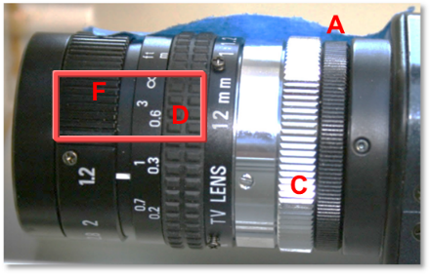
    - Use the C-CS mount adapter (5mm silver knurled ring (C) shown in the picture). The camera in this picture has a CS adapter (A) already included as part of the camera (the black 3.5mm knurled ring on the right).

A few comments:
The Watec camera comes with a 3.5mm black knurled ring adapter (A) that provides an interface between the camera opening and the lens. This 3.5mm adapter (A) is considered part of the camera. With that adapter, the camera is considered a CS style camera, which expects a 12.50mm backfocus lens. This 3.5mm adapter is designed to be adjustable to suit a variety of lens designs.
However, for our use, this adapter is between 0.7 and 0.9mm and is too thin for the C-mount lens we're using while screwed all the way in. This Pentax lens is a C-mount lens, meaning that it has a 17.56mm backfocus. Therefore, with the additional knurled silver 5mm C-CS-mount adapter ring depicted (C), it should reach focus on stars with the lens set to near infinity. However, because the 3.5mm adapter (A) is still too thin, the lens will reach focus on stars (infinity distance), but only with the focus set to about 10 inches (D), instead of the infinity setting. Also, the smooth silver ring (E) is considered part of the lens. The right- most point of (E) is where to measure the 17.56mm from. (D) is the focus ring and (F) is the aperture ring.
To reach focus, you have three choices:
      - As-is - Screw the 3.5mm adapter (A) all the way in and set the lens to about 10 inches (D); You can mark the lens with a silver Sharpie pen where the infinity focus setting is for future reference. This is probably the simplest and recommended approach. It only affects the FOV and image scale very slightly.

      - Calibrated - Set the lens focus setting to near infinity (not all the way to infinity because you have to be able go past infinity while focusing to tell that you've gone too far to know where the focus setting should be) then loosen the hex set screws (C) for the 3.5mm adapter (A) and unscrew the adapter (A) (probably about 0.8mm) while imaging until it is in focus. Then tighten the set screws (C).

      - Without the 5mm C-CS adapter ring (C), set the lens focus setting to near infinity (not all the way to infinity because you have to be able go past infinity while focusing to tell that you've gone too far to know where the focus setting should be) then loosen the 3 hex set screws (C) for the 3.5 mm adapter and unscrew the adapter (probably around 5mm) while imaging until it is in focus. Be sure to re-tighten the set screws. There is a drawback to this method - the lens may not be stable in this configuration because the 3.5mm adapter is unscrewed so far. It will be wobbly during focus and you may find it difficult to retain the same focus setting after re-tightening the setscrews after making focus

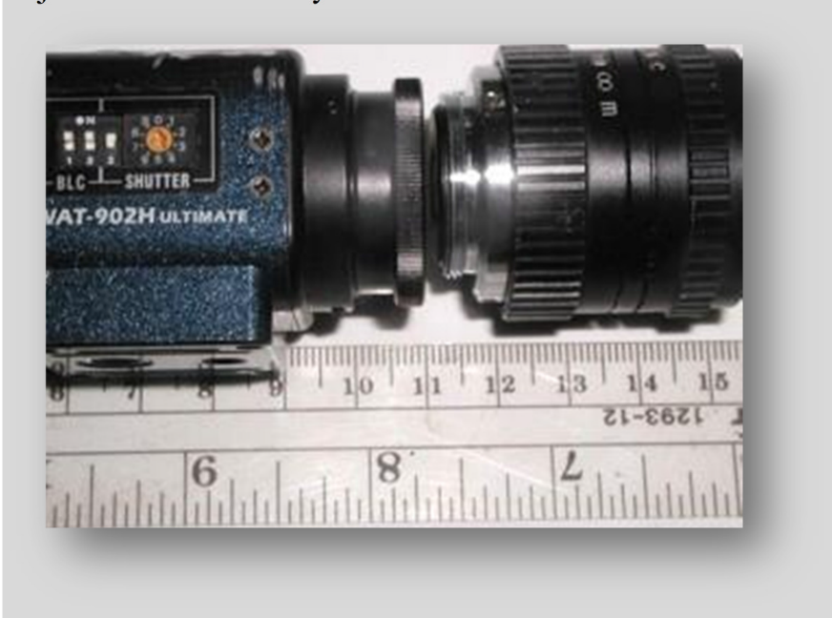
adjustments while they are loose.
Since the second method doesn't really improve anything, I feel that the first
method is the easiest and is what I would recommend.

The next picture shows the spacing required to get the lens to focus on stars at the near infinity focus setting with the 5mm C-CS adapter properly installed.

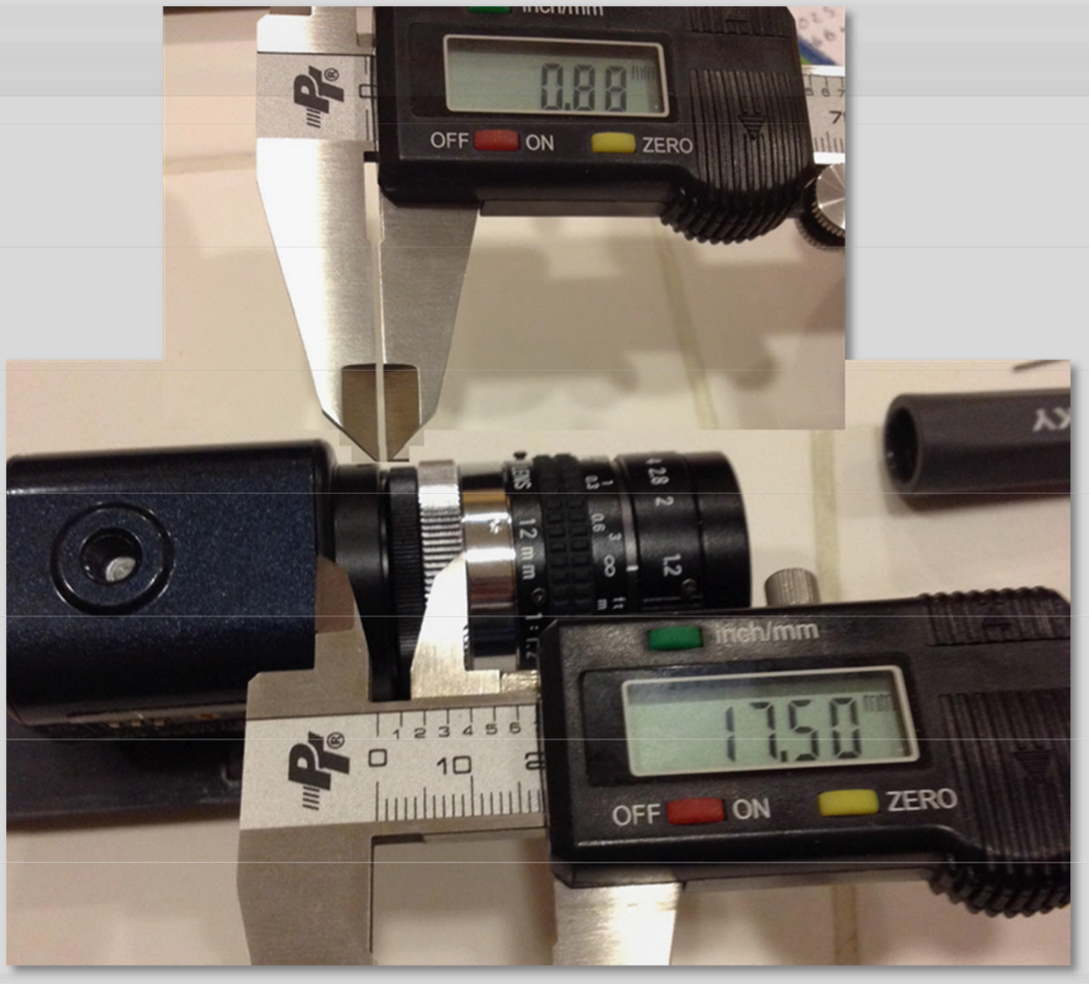

The total lens backfocus for a C-mount lens is about 17.56mm. This is measured when the lens is at focus on something at infinity distance. Note how, in this image, the black 3.5mm adapter (A) is unscrewed 0.88mm instead of unscrewing the 5mm silver adapter (B). This image shows the correct approach to calibrating by unscrewing the adapter to correct the spacing if you elect to do it this way. You can see in this image that the focus setting is near the infinity mark and the focal ratio is set to f/1.2.

Note where the 17.50 mm is measured from. The right side of the knurled silver ring (C) is the back plane of the lens where the measurements are taken from. Also note that there is a 0.88mm gap to the left of the 3.5mm adapter (A). This is the correct place to adjust the spacing.

Note that the focus mark is set to near-infinity and there is a 0.88mm gap.
    - Set the aperture setting all the way open (f/1.2).

Note: If you are experimenting with this in the daylight, you will notice that a higher focal ratio/aperture setting will allow you to see things in the room or outside. However, this will cut out a lot of light during the evening and reduce

the effectiveness of the data. Be sure that when you finally configure for evening meteor recording that the aperture is set to 1.2.
    - Focus the lens so that it is either about where you see it in the picture or so that the infinity symbol is under the 1.2 notch, depending on which adapter configuration you have. You will fine-tune the focus once the system is inside the weatherproof enclosure, the software is installed, and it is dark enough to capture stars in the camera.
  - Set up the weather-proof enclosure and wiring.
    - Clean the window inside and out while you have the chance to get your hands inside. The glass often ships with a slight hazy film over it and this will be your last chance to clean it without removing the camera and recalibrating, etc.
You should also plug all the holes to keep spiders and bugs out. You should plug the holes with some kind of waterproof fine mesh to all the system to breathe.
    - Mount the camera to the plastic mounting plate to the forward-most position on the plastic plate. If the plastic mounting plate is already attached to the rails, you have two choices for mounting the camera to the sliding plastic mounting plate:
      - Unsnap the plate from the rails. It might be a little difficult, but you can try to jiggle and force the plastic mounting plate out of the rails. Attach the camera with the provided 1/4 - 20 screw; then snap the plastic mounting plate into the rails.
      - You can remove the back of the enclosure using the small screws and slide the plate out the back. Attach the camera with the provided 1/4 - 20 screw; slide the plate back on to the rails; and replace the back of the enclosure.
    - Attach the plastic mounting plate to the rails with a screw, attach the mounting plate far enough back such that the end of the lens is about 3/8" from the inside window of the enclosure. You need to ensure there is a cushion of air between the window and the lens so as not to capture humidity between the two. Also, it is a good idea to leave enough room to be able to unscrew the lens for whatever reason without having to remove the camera from the rails.
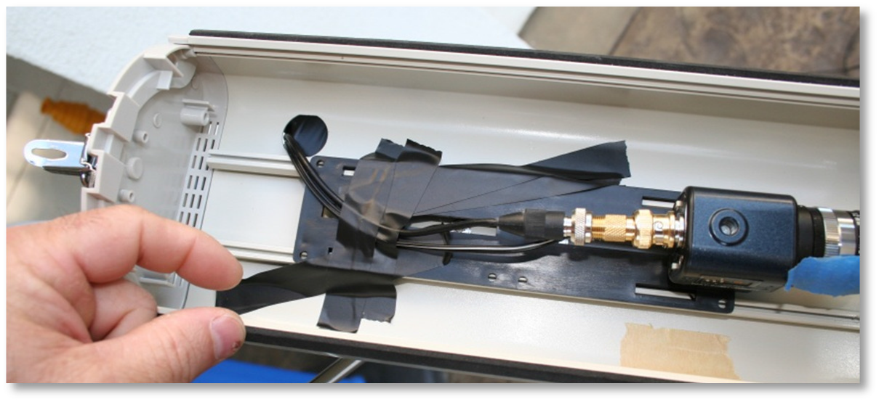

Update: Don't use tape as shown in the picture. The tape didn't work for more than 2 months. I eventually put a screw through the plastic platform into the rail to prevent the plastic platform from slipping. The problem became evident when I started to see some vignetting near the bottom of the FOV.to prevent the plastic platform from slipping.
    - Thread the video cable separate from the power adapter cable so that you can later change the configuration by placing the power supply inside the enclosure during the winter to warm the enclosure. You will thread the video cable through the cable punch-out at the bottom-rear of the enclosure. My enclosure came with some plastic cable grommets to protect the cables from chafing. However, I had to remove them in order to get the F-connector through.

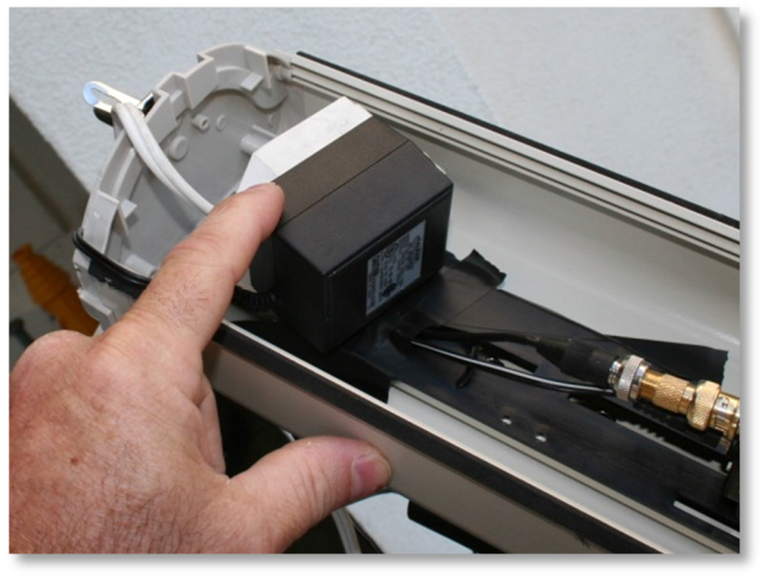
    - Attach the enclosure to the tripod.
Here, the enclosure is pointing downward.
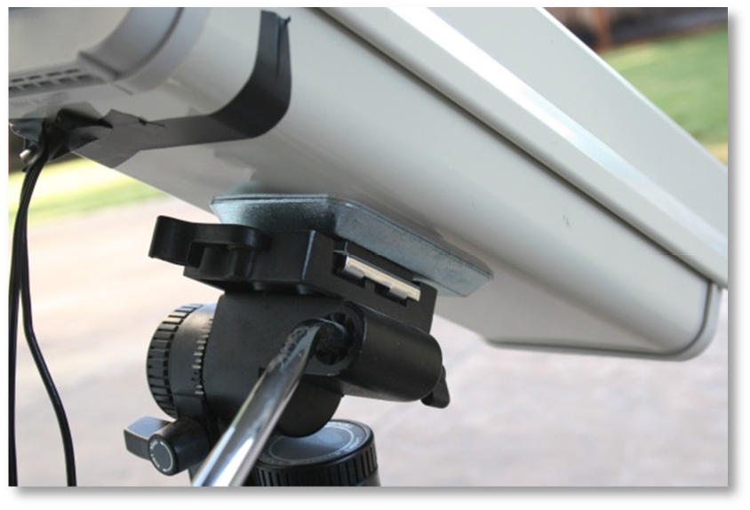
    - Attach the video cable to the BNC Male to F Female adapter and then attach that to the camera's BNC connector. Then tape the video cable to the plate as shown in the pictures. Also attach the 12vdc power connector to the camera and secure the power cable to the adapter plate with tape.
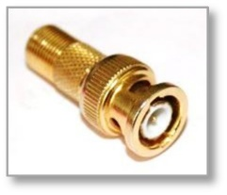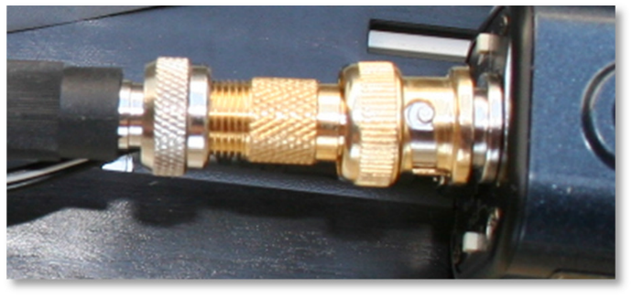

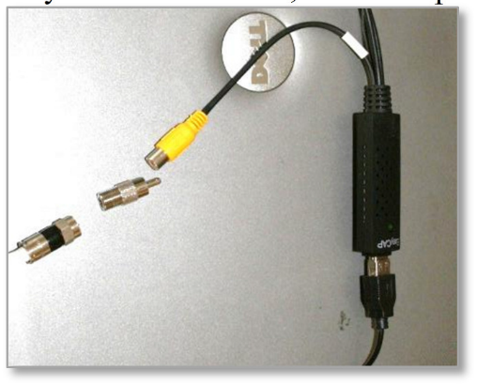
    - On the other end of the video cable, connect the F Female to RCA Male adapter. You can also connect the RCA Male adapter to the yellow female plug on the EasyCAP at this time, but don't plug the USB cable into the computer yet.

    - Connect an extension cord to the 12VDC power supply. Connect the other end of the extension cord to the wall timer. Configure the timer for photoelectric mode or run CheckTwilight to determine the Wall Timer ON and Wall Timer OFF times and then plug the timer into an outlet. Cover the timer and all connections with saran wrap or something to protect against the rain and dew. There is a report on the web that states that the timer isn't even splash resistant.

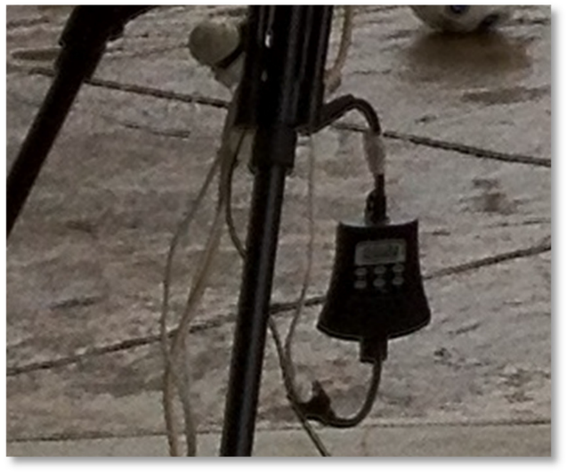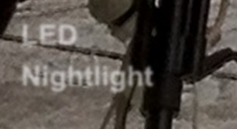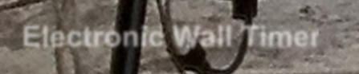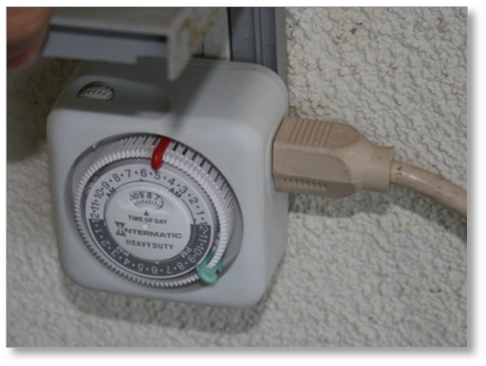
LED
Nightlight
Electronic Wall Timer
Electronic Wall Timer Mechanical Wall Timer

Update: I found that attaching the wall timer to the wall on the porch, which is now out of the weather, I don't have to worry about rain getting onto the timer. Also, since I'm running two cameras now, and I've moved the camera mounts to another part of the backyard, it is beneficial to me to have the LED nightlight also connected to the wall timer so I can check whether the power is on without going outside. Without the nightlight, there is no indication whether the power is on.
    - There is also a portable GFCI available for about $13 that provides a level of safety against water intrusion on your electronics. Plug this into the wall, then plug the timer into the ShockBuster, then plug the extension cord to the timer.

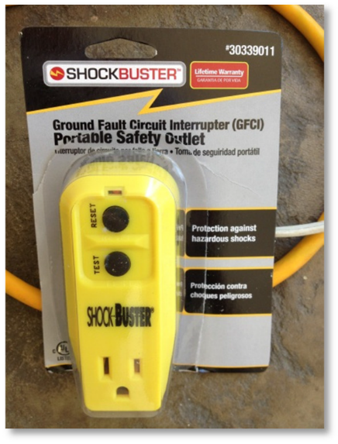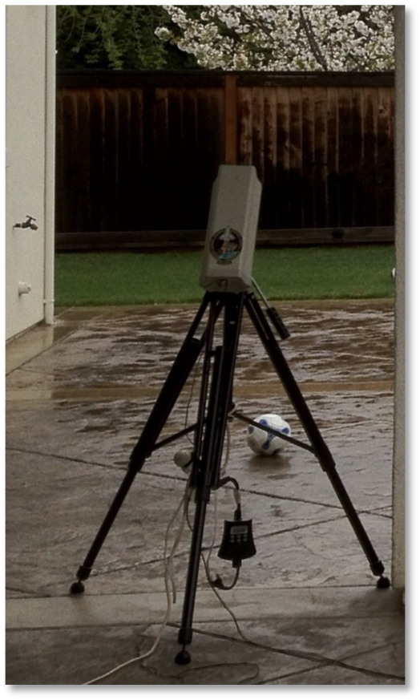
    - Tape the punch-out hole to prevent bugs and water from entering the enclosure.

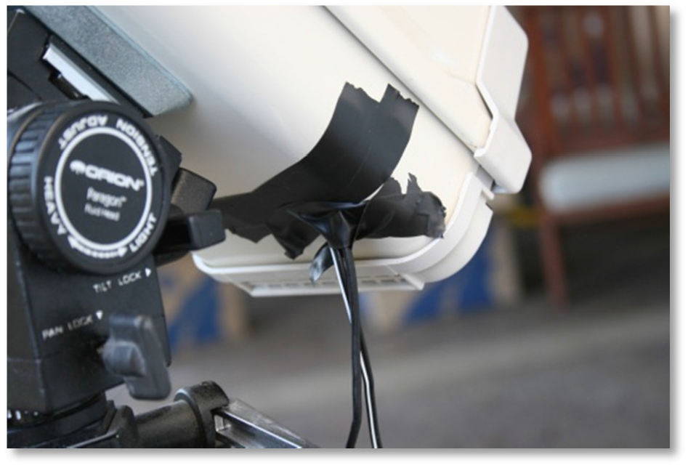
  - Install the video capture driver from the manufacturer.
  - Install the video capture software from the DVD.
The reason to install the video capture software that comes with the capture card is so that you can use it to test the video connection in case something goes wrong and also to configure the driver. It is always best to test the hardware with the software that comes with the hardware.
  - Configure and test the software... ensure that you get an image. It should be a white image. Unplug the video cable from the video capture device and it should go black. Plug it in again and it will go white. If you have set the shutter to the 1/100,000th second setting, you should be able to turn the SHUTTER switch 3 to ON. You should be able to see images in the daytime for preliminary adjustments and preliminary focusing. Just be sure to switch it back to OFF.
  - Reboot

Task 2 - Clock Synchronization (IMPORTANT!)
For this project, it is imperative that the clocks of all systems are synchronized to a certain level of accuracy from the UTC standard. We don't care how you maintain your Windows clock, we just require that you keep it synch'd. within about 0.5 seconds of UTC. You should know that Microsoft Windows only synch's the Windows clock at boot up. After that, for months, it uses the Windows clock. As it turns out, the hardware clock on PC's are fairly accurate - typically enough for about one day of processing. A typical Windows system will synch with the PC hardware clock once upon boot up and then use the Windows clock after that.
However, the Windows clock can be out of synch by several seconds to even a minute within a few minutes of booting up! There are a few solutions to this. One is to use a GPS device to keep the Windows clock in synch every few minutes. This requires extra equipment and adds expense, but it would be a good approach (especially if you have no internet), as long as it synchs the hardware clock with each new synch. The other is to use a utility like Dimension 4 or Meinburgh, which use the NTP time servers and synch to those time servers frequently - and it synchs both the hardware clock and the Windows clock at the same time. At an even more frequent interval, it synchs the Windows clock to the internet time. Therefore, you can configure Dimension4 to synch with an NTP time server every 4 minutes. Doing this has been shown to keep the Windows clock accurate to 0.01 - 0.5 seconds.
It's important to use a reliable time server. Instead of using one server, which could go offline without warning or even cut you off for hitting too often, use a pool server, such as pool.ntp.org. See NTP support site for more information on pool servers.
To configure Dimension 4 to use a pool server, open Dimension 4 and:
    - Click the Settings button. The User Account Control dialog should appear.
    - Click Yes.
    - The Settings button changes its label to “Advanced”.
    - Click Advanced. The Advanced Settings dialog appears.
    - In the Server Selection group, select: Use the selected server.
    - Click OK.
    - Click the Add button.
    - For Server, enter: pool.ntp.org
    - For Location, enter: WORLD: pool.ntp.org
    - For Notes, enter: Global pool server
    - Click OK.
Set the How Often field to synch every 5 minutes. Watch it for a day. Then click on History to see the synch history. Select Last 24 hours. If any of the synchs except for the 4pm synch is greater than 0.5 seconds, then decrease the synch interval by one minute each time until you get 0.5 seconds as the maximum synch. Don’t expect to get it much better than 0.3 seconds.
https://support.ntp.org/bin/view/Servers/NTPPoolServers

Dimension4 can be downloaded from the following URL:
http://www.thinkman.com/dimension4/download.htm

Task 3 - Introduction to the AutoCams and Cams Programs
The CAMS programs are an assortment of stand-alone console programs developed in C++ by programmer/scientist Pete Gural. Typically, console programs are executed from a command prompt (also known as a DOS window). The original AutoCams was a DOS batch scripting language-based menu driven "wrapper" around the CAMS console programs. The AutoCams menu system was designed to facilitate your daily workflow by first selecting the date/capture session, then stepping through the menu options. When Pete released the CAMS 2 version of the CAMS programs, they were incompatible with the AutoCAMS scripts. Steve Rau (BeNeLux) developed the LaunchCapture.exe program, which handles much of standard capture and some post-capture processing activities. Steve also developed the CamsGUI.exe program. These tools were written in Delphi (pascal) programming language. They are compiled and the source code is not available. Since then, Dave Samuels’ AutoCams scripts have been adapted to a hybrid of using Steve’s LaunchCapture system in conjunction with Pete’s CAMS 2 programs in order to achieve fully autonomous operation. Most of the CAMS systems worldwide are using this hybrid fully autonomous AutoCams system. Using this approach, you are not required to manually upload the daily data to the server and you are not required to manually stop and perform manual meteor confirmation before the remaining steps are performed. The AutoCams2 system can run for months at a time without much intervention by the site operator. Most of the intervention required with AutoCams2 is fixing problems, such as noisy cameras, which are pointed out in the daily status reports that are uploaded to the server. What is required now is a fair amount of monitoring of the status reports. Even though the system runs autonomously and it is very resilient, there are still conditions that cause the hard drive to fill up.
Note: Most of the CAMS programs can be run either from a command prompt or by double- clicking on them from Windows Explorer. When these programs require input, a File Open dialog appears that allows you to navigate to and select a file or directory for the program to work on. In other places, you are prompted within the console window for input in the same manner as the old 1980s style DOS programs input.
The Autocams scripts, which also run from a command console, and are run from a command line. However, you can get some quick help by entering the command followed by a space and then /H or /?.

When the CAMS programs run, they produce results - typically by placing files into subdirectories at a location controlled by the user. These subdirectories are called the “working directories”. At the same time, they often display scrolling information and/or results in the same console window or adjacent console windows. The resulting files sometimes need to be examined or manipulated before running the next program in the process.
The order in which the programs are to be run and manipulation of the results in preparation for the next step in the process is called the "workflow". Knowing which program to run in the correct order and how to locate and manipulate the results in preparation for the next step in the workflow can be difficult to teach to the average user. A menu system, CamsGUI.exe, was created by Steve Rau and was designed so that it has many of the same choices from original AutoCAMS version 1 menu. It helps the average user to repeatedly produce consistent and accurate results. If you are not required to stop and manually perform confirmation and upload, then AutoCAMS was designed to run the amateur CAMS systems autonomously, night after night, until the hard drive is full. Using AutoCams2 in autonomous mode, there are only a few situations where the user has to interact with the system, such as:
- Performing a manual calibration for those nights when automatic calibration was not achieved.
- To resolve errors when they occur.
- When the disk full warnings appear.
- Maintaining permanent archive backups.
- Performing the optional Confirmation task (which can't be automated yet).
The optional CamsGUI menu system takes some getting used to. Documentation for LaunchCapture and CamsGUI can be found here (https://www.meteornews.net/cams/7-cams-manual/)
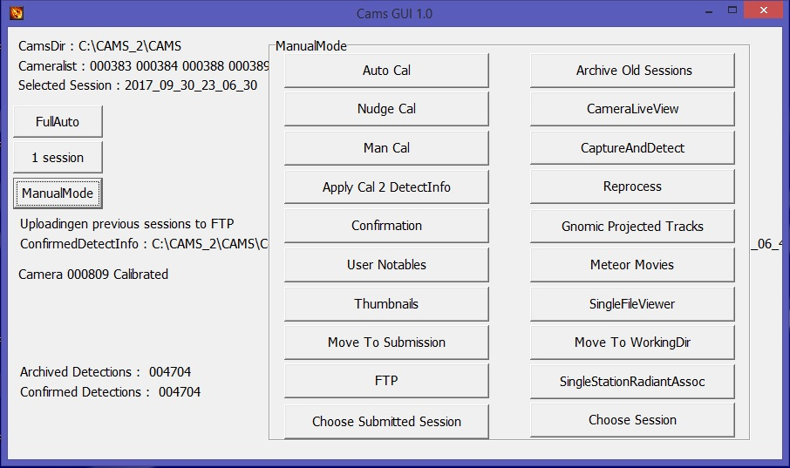
Steve’s CamsGUI program

Task 4 – Daily Workflow
Here is a brief rundown of how the autonomous AutoCams 2 system works with regard to the times of the day it needs to be powered on (all times local). There are several scheduled tasks that need to run - most of them each day - for full autonomous operation.
- At 5pm each day, the system runs the LaunchCapture.exe program using the Cams2 LaunchCapture Board <n> scheduled task. Since there is no practical way of dynamically changing the LaunchCapture launch time based on sun angle, we run it at the earliest time of the day of the earliest capture time of the year. (Mid December nights are the longest, with the earliest time it is dark enough to capture around 4:30 - 5pm) When LaunchCapture.exe starts, it checks the date and calculates the "actual" capture time (when it is dark enough based on the sun angle specified in the CamsGUI.ini file) to start recording. Then it puts itself into a sleep until the actual capture time. At the actual capture time, it awakens, calculates how long it should capture (duration - based on the specified sun angle), and starts capturing. Therefore, the PC should be on BEFORE 5pm each day (I'll explain the "before" part next). Power to the cameras doesn't need to come on until dusk. Many stations use a timer with a photocell to turn power on to the cameras. This works ok.
- At 4pm each day, the standard scripts reboot the PC using the Cams2 Reboot PC scheduled task. We do this because experience has taught us that the PCs sometimes just get hung up in one way or another at times when we least expect it. Sometimes, it's just the network interface. Other times, it is a frozen application that has locked itself up. Very seldom, but it does happen, some of my scripts get hung up. Another cause is that sometimes applications pop up a modal dialog, which can lock the system up indefinitely (until someone logs in and closes all the dialog boxes). When the network interface, or windows itself is locked up, we can't remote into it and solve the problems. Rebooting the PC once per day helps with this a lot. With the daily reboot, we still have cases where someone actually has to go out and fix something or turn the power on. However, since we have started rebooting, aside from those rare cases where someone has to actually go out and fix something, we only have to wait until 4pm the next day to be able to log in and work on the system. The reason we chose 4pm is because sometimes when it boots, there are some required windows updates or other kinds of things that run and some of them can take some time. We want all that extra stuff to be completed before the 5pm LaunchCapture start.
Therefore, the PC needs to have power at least a few minutes before 4pm each day. The time of this can be adjusted, probably as late as 4:30pm, but probably not much later than that.
- At 4:50 each day, we run Cams2 LaunchCapture_KILL scheduled task. This is a task that kills all CAMS related tasks in order to clear the way for the next day's new capture sessions. It also checks the weather at ClearOutside.com for your location to fetch a weather html file for the upcoming capture session. Another thing that it does is to cycle the log files. In order to keep the log files from growing endlessly, we cycle the logs once per day through 7 days. The final thing that it does is to copy the all the CamsGUI.ini.bak files to their respective CamsGUI.ini files. This is done in order to avoid some issues that we have seen come up before.
- At 3pm, we run the daily Archive routines using the Cams2 Archive schedule task. These are extremely important for a remote autonomous system because it's the script that keeps the hard drive from filling up. The time for this can be adjusted. However, you need to ensure that this activity doesn't overlap with other post-capture processing from the morning. Therefore, it is probably also good to set a trigger for the CAMS2 Reboot PC task to run at about 2:45 pm. Depending on how long it has been since this task ran, this task can take an hour or so to run. It is designed to be resilient, in that, if it fails (let's say because the system is rebooted during archiving) it will re-archive the sessions that didn't finish the next day.
- At the end of the night, let's say, around 6am, the capturing stops and LaunchCapture begins its post-capture processing. It's not always at the same time because capturing ends based on sun angle, which changes throughout the seasons. If you have multiple CAMS instances (each Sensoray capture card requires a separate CAMS instance in a separate directory), the post-capture processing works backward. For example, if you have 2 instances of LaunchCapture running (because you have 2 Sensoray capture cards), the post-capture processing for Board 1 will need to complete before the Board 0 LaunchCapture instance begins its post-capture processing. Furthermore, if there any old capture sessions that did not get to complete their post-capture processing for board 1, then those are then processed until all of them are completed before board 0’s post-capture processing commences.
Post-capture processing consists of 4 main phases:
  - Validation – The first thing that LaunchCapture does with regard to post-capture processing is to iterate through each FF file in the capture session’s CapturedFiles directory and check if it is corrupt. If it is corrupt, the file is renamed with the “.bad” extension instead of the normal “.bin” extension. This process takes a long time, since you might have 16 cameras on a 14 hour winter capture night. That would mean about 100,000 or more FF files that have to be checked.
  - AutoCal - We iterate through all the captured files, ordered by camera, skipping a few minutes between samples, and compare the image of the night sky against a database of stars (magnitude 8.5 or brighter). Then we create CAL files that are used to determine the exact locations of the center of the FOV of the camera for that night. CAL files contain the RA/DEC, ALT/AZ, FOV, and other information related to the calibration for the time the FF file was captured. These calibrations are later used during meteor detection to get very accurate sub-pixel coordinates for each frame of the event.
  - Detection - (sometimes called "reprocessing" because of an old name. Also sometimes called "meteor scan".) Detection uses FTP_DetectMultipleFF.exe and FTP_DetectSingleFF.exe. It is a multi-threaded program that scans each FF file for streaks, given certain thresholds as specified in one of the config files.
  - Transmit - This phase us launched by the Cams2 Upload_Queue task. There are two upload routines and it is important to use only of them. If you are in BeNeLux network, then you can allow LaunchCapture to perform the transmission. If you are not in BeNeLux, then uploading/transmitting to the NASA server is done outside of LaunchCapture and it is not part of the LaunchCapture.exe’s post-capture processing. LaunchCapture.exe’s upload function must be disabled or the two upload routines will conflict. To disable LaunchCapture.exe’s upload, you open the “CamsGUI.ini.bak” file, navigate to the [FTP] section, and set ftpupload=false. The Cams2 Upload Queue task calls the upload_queue_START.bat script. It's a special script I wrote that does the following: (1) creates a zip file for each session, that hasn't already been transferred, into the queue. (2) Once all the transfer zip files are created, it iterates through each and attempts to upload. This script is designed to be resilient against all sorts of failures. Whatever the failure, it can pick up and finish from where it left off. It can even determine if an upload only partially succeeds and forces a retry.
- All these phases can take some time. If you have 16 cameras on a slow computer (maybe because the CPU is fast but the hard drive is slow), post-capture processing can take from 1-3 hours for a normal capture session... sometimes even more. We need to leave the PC on long enough for the first week or so in order to determine how long it takes to process the average night's capture sessions. I've seen some computers able to finish by 9 am while others take until 2pm. We have to determine this by running for a week or so. Until we can determine the actual average, we need to leave the PC on all day to give it a chance to test and to gather information.
- If any maintenance needs to be done on the system remotely, it will likely be done during by us during Texas daylight hours 8am until 8pm let's say.
Important Note: Various parts of the system will move files autonomously, when you don’t know it will do it. For that reason, it is extremely important to never lock a file or directory. How would you lock a file or directory? Using Windows File Explorer to navigate to directory will lock that directory. Yes, it is true, that, for example, if you use the Windows File Explorer to navigate to, such as “D:\Cams2_Board0\CAMS\CapturedFiles”, will lock the entire directory. If one of our scripts or programs attempts to move the directory to SubmissionFiles, or if the archiving scripts attempts to cull files and move them to the Archive drive, the script or program will fail and break the script. The directory will remain in place and will not be moved. Likewise, opening a file in one of our directories with a program like Notepad will also lock the file. So, when AutoCAMS attempts to move a directory, all the files in the directory will be moved except the file you have locked AND the directory will still remain. This is why we install TotalCommander and TextPad on all the systems.
To avoid this problem, use TotalCommander to navigate and copy and move files and use Textpad to open files for editing. Also, TotalCommander has a View tool to view the contents of files without opening them for edit. None of the tools lock the files.
One of the things that has happened in the past is when I’ve used Windows Files Explorer to quickly navigate the file system, but then to lose the TeamViewer or DWService connection for a while. Later to find out that the system failed to move a directory because I couldn’t close the program before it attempted to do its work on it.
Therefore, NEVER USE WINDOWS FILE EXPLORER OR NOTEPAD.
Autonomous AutoCams 2 - In autonomous mode, all automatic steps are performed as configured. When the Windows Task scheduler is properly configured and a good wall timer is installed to control the power to the cameras, all necessary functions are performed and completed a few minutes to an hour after capture completes. Logs are created and stored in the session's Logs directory until LaunchCapture completes. During post-capture processing the Working directories are packaged into their SubmissionFiles directory, each named after the Capture session start time and the first camera. At that point the LaunchCapture logs are also moved into the "SubmissionFiles\<date>_<camera>_<time>\Logs" directory.

Update:
Sometimes FTP transfers fail for various reasons. Sometimes this failure occurs before an upload transmission has time to complete. This leaves a partially uploaded corrupt file on the FTP server. To avoid this, we now determine whether the file is corrupt or not by downloading the zip file immediately after uploading it, performing an MD5 encryption hash check of the downloaded file, and comparing that with the MD5 encryption hash of the file before it was uploaded. The hash codes should be identical. Finally, it unzips the downloaded file and checks for corrupt zip file by checking the success or failure return code from the zip program. This should tell indicate whether the file needs to be re-uploaded. AutoCams can be configured to add a sequence code to the zip file for each attempt, since it is assumed that you don't have delete privileges on the FTP server in case the server changes permissions to no allow overwrites and deletes. This function is not deeply tested.

Note: The AutoCams 2 system is an assortment of batch scripts. The source code for the scripts can be modified by a knowledgeable person. For example, if the scripts don't function properly, you do not need to wait for someone to fix them. However, it is best to communicate any required changes to Dave Samuels (dave@davesamuels.com) so that a new version of the scripts can be properly maintained, versioned, and distributed with the changes. Making extensive changes to the scripts on your own may prohibit us from being able to provide assistance.

Note: A unique naming scheme was required to avoid loss of data by the overwriting of multiple capture sessions from the same camera on the same night. Some have suggested that this is an infrequent situation, but experience is showing that it is more frequent than we assumed. The .EXE programs were not changed to accommodate these name changes. Therefore, if you don't use AutoCams 2, you will eventually lose data unless you manually take the necessary steps to avoid overwrites. Thus, the scripts perform these directory and filename changes outside of the programs and change the names back to names that are compatible with the .EXE programs when they require it. This will add some confusion in the beginning, but I'm sure it will be clear as people get used to it. Doing this will allow the computer to make appropriate autonomous decisions without user intervention. These changes will involve the following name changes:
- FTPdetectinfo_0ccc_yyyy_mm_dd.txt will change to: FTPdetectinfo_0ccc_yyyy_mm_dd_hh_mm_ss.txt
- The zip files will change the name from: yyyy_mm_dd_ccc.zip to: yyyy_mm_dd_ccc_hh_mm_ss.zip
or yyyy_mm_dd_ccc_hh_mm_ss_#.zip
- Stripping the headers from the detect files will no longer be performed. The detect files in the ArchivedFiles and ConfirmedFiles directories will be named as follows and these will also be copied into the EmailFiles directory. The zip file will contain only the necessary files to perform coincidence and re-calibration if necessary:
FTPdetectinfo_0ccc_yyyy_mm_dd.txt to: FTPdetectinfo_0ccc_yyyy_mm_dd_hh_mm_ss.txt FTPdetectinfo_0ccc_yyyy_mm_dd_hh_mm_ss_scanned.txt (in the zip file)
and
FTPdetectinfo_0ccc-#.txt to: FTPdetectinfo_0ccc_yyyy_mm_dd_hh_mm_ss.txt FTPdetectinfo_0ccc_yyyy_mm_dd_hh_mm_ss_confirmed.txt (in the zip file)
The "_scanned" and "_confirmed" suffix is used to differentiate between the detect files from those operations. The original CAMS programs do not take this into consideration.

- FTPdetectinfo_0ccc_yyyy_mm_dd.txt will change to: FTPdetectinfo_0ccccc_yyyy_mm_dd_hh_mm_ss.txt
- The zip files will change the name from: yyyy_mm_dd_ccc.zip to: yyyy_mm_dd_ccc_hh_mm_ss.zip
or
yyyy_mm_dd_cccccc_hh_mm_ss_#.zip
- The detect files in the ArchivedFiles and ConfirmedFiles directories will be named as follows. The zip file will contain only the necessary files to perform coincidence and re-calibration if necessary:
FTPdetectinfo_0ccc_yyyy_mm_dd.txt
to:
FTPdetectinfo_0ccccc_yyyy_mm_dd_hh_mm_ss.txt FTPdetectinfo_0ccccc_yyyy_mm_dd_hh_mm_ss_scanned.txt (in the zip file)
and
FTPdetectinfo_0ccc-#.txt
to:
FTPdetectinfo_0ccccc_yyyy_mm_dd_hh_mm_ss.txt FTPdetectinfo_0ccccc_yyyy_mm_dd_hh_mm_ss_confirmed.txt (in the zip file)
Sometimes, a "_scanned" and "_confirmed" suffix is used to differentiate between the detect files from those operations. The original CAMS programs do not take this into consideration.

Task 5 – Directory Structures
Directory Structure - The CAMS directory structure is quite specific. You can install the CAMS software on any directory of any drive. However, the directory structure inside that starting location is specific. The default installation location is C:\CAMS. For this documentation, we will assume that the executable directory is "C:\CAMS". If you installed the software under "F:\astronomy", you would need to place all the executables and scripts into "F:\astronomy\CAMS". The software requires that the directory from which the program is run is called CAMS. If you set the Starting Location to "F:\astronomy\CAMS", the software will assume that the software and subdirectories is under "F:\astronomy\CAMS\CAMS".
Several subdirectories of CAMS are used for various file management reasons. Some have names that are dictated by the .exe programs and others are dictated by the AutoCams scripts. The required directory structure for the .exe programs is as follows (assuming C:\CAMS as the home directory):
ArchivedFiles
Cal
CapturedFiles ConfirmedFiles
Important Note: These 4 directories are referred to as the "working directories".
There are some 4 additional directories that are required for AutoCams 2:
Logs
SubmissionFiles
Submitted
Temp

CapturedFiles - Contains the image frames captured by the camera(s). A new subdirectory is created each time the capture is started. Each subdirectory is named according to the date and time the capture was started. For example, 2011_12_13_01_56_38. The date and time represent the UTC time (Zulu or GMT if you prefer). If you stop capture and start it again on the same date, you will have two capture subdirectories (we call those “capture sessions”). For example, if you stopped capture and restarted on 2011_12_13 at 02:10:14 UTC, you'd have both directories (2011_12_13_01_56_38 and 2011_12_13_02_10_14) under the CapturedFiles directory. Each subdirectory under CapturedFiles contains primarily files following the naming pattern of FF*.bin. We often refer to these in conversation as the "FF files", or sometimes referred to as “.bin files". Each of these files represents about 8.5 seconds of video (specifically, 256 frames at your frame rate
29.97 NTSC or 25 PAL) (8.5 seconds for NTSC and 10.24 seconds for PAL). The file names are encoded with the camera number, UTC date, UTC time, milliseconds, and frame counter. Each FF file for an NTSC video camera is 1,228,820 bytes. This directory can be quite large on a winter night of over 12 hours of capture (5400 FF files per camera!). Each FF file’s name pertains to the date/time of the start of the capture of that frame.
Cal - Contains the calibration files. All the calibration files follow the naming pattern of CAL_*.txt. These file names are also encoded with the camera number, UTC date, UTC time, and milliseconds. The UTC time is often 4.27 seconds (5.12 seconds for PAL) different from the matching UTC time in the matching FF file that was used for calibration. This is because the calibration file names use the middle of their 8.542 seconds (10.24 seconds for PAL) and the FF files use the beginning of their capture time. Also, in the Cal directory is the CameraSites.txt file. This file contains camera number, the Lat/Long and altitude, the name of the camera settings file that describes the camera, and the name and abbreviation of your site for each of your cameras. In addition, the camera settings files (e.g. w902H2U_12mm.txt) are kept in this folder for the programs and scripts to read to determine the camera properties. In the CameraSites.txt file, it is important to pad the camera numbers with leading zeros so that each camera number is exactly 6 digits. If you move one or more cameras more than 30 meters, it is important to create a new entry for each camera that was moved more than 30 meters.
ArchivedFiles - This directory contains a list of subdirectories that are date/time encoded similar to how the CapturedFiles subdirectories are encoded. Each date/time encoded subdirectory contains a subdirectory that contains a detection file as well a copy of each FF file that has one or more detections in it. The ArchivedFiles subdirectory contains a subset of the files from CapturedFiles, on average between 1/7th to 1/20th of the number of files in the CapturedFiles subdirectory. If you have a noisy camera, the ArchivedFiles subdirectory could contain ½ of the FF files from its corresponding CapturedFiles dir. (we prefer to avoid that situation)
The detection file is named according to the following pattern: FTPdetectinfo*.txt. There are a few different variations of the name of this file. So, most of us just call it the "detect file" for short, while some call it the “detectinfo file”.

Timeframe | Detect file naming scheme
2011 Aug - 2011 Dec | FTPdetectinfo.txt
2011 Dec - 2012 May | FTPdetectinfo_0cc_yyyy_mm_dd.txt
2012 May - 2013 Jan | FTPdetectinfo_cccCCC_yyyy_mm_dd.txt  (multiple cameras are supported)
2013 Jan - 2017 | FTPdetectinfo_cccCCC_yyyy_mm_dd_hh_mm_ss.txt  (Accommodates multiple sessions per night)
2017 - present | FTPdetectinfo_0ccccc0CCCCC_yyyy_mm_dd_hh_mm_ss.txt  (Accommodates multiple sessions per night, 6-digit cameras)

In Jan, 2013, after working with multiple submissions for multiple stations for performing and scripting Coincidence processing, it was determined that the May, 2012 naming was still insufficient for handling multiple sessions on the same night with the same camera - whether the camera was in the same position or whether it was moved for each of those sessions. Due to lack of consensus, the CAMS.exe programs were not modified to accommodate this requirement (and it is a requirement). Starting with the Jan, 2017 release, the scripts accommodate for this using the following naming scheme for the detect file:
"FTPdetectinfo_0ccccc0ccccc_yyyy_mm_dd_hh_mm_ss.txt"
where 0ccccc0ccccc is the first camera number and the last camera number. 6-digits per camera number with zero padding.
or
"FTPdetectinfo_cccccc_yyyy_mm_dd_hh_mm_ss.txt"
Where cccccc is just the first camera number, which is all that is required to uniquely identify the submission. 6-digits per camera number with zero padding.
There was also a time where the detect file date/time stamp reflected the time of the first detection, which was almost always different from the CapturedFiles date/time stamp. Having them the same was another convenience that we try to maintain, but you might find use cases that we didn't accommodate for in the scripts.
ConfirmedFiles - This directory contains a detection file that refers to only those detections that are manually tagged and confirmed as meteors or those where it is too difficult to tell whether it is a meteor or a bird or something else. (When in doubt, confirm it). The ConfirmedFiles directory has subdirectories similar to the subdirectories of the CapturedFiles and ArchivedFiles. The number of files under the ConfirmedFiles subdirectory is often 1/10 to 1/20 of the number of files in the ArchivedFiles directory... or about 1/70th to 1/200th of the number of CapturedFiles.
------------------------
The remaining directories are used by the AutoCams 2 scripts:
Cal\BinFiles Logs SubmissionFiles Submitted
Temp

Cal\BinFiles - This directory is a directory used by the AutoCams scripts. It was created so that a copy of the FF file used for calibration could be stored in case a subsequent night's processing requires it. We refer to one of these FF files as the "FF file used for calibration". For example, suppose that 2012_08_11 was a good clear night and a valid calibration was made. The FF file used for that calibration is stored in the “..\CAMS\Cal\BinFiles” directory. The next morning you perform some maintenance and clean up the existing directories and archive them to make space for new data.
Now suppose that on 2012_08_12, the sky was too hazy to obtain a reliable calibration. Using the good calibration from 2012_08_11 would be fine, but the CapturedFiles directory for that night may no longer exist in your Working Folders because of the maintenance performed. Without a copy of the FF file used for calibration from the 2012_08_11 night, you would not be able to include the "FF file used for calibration" with the submission. Having a copy in the “..\CAMS\Cal\BinFiles” directory solves this potential problem.
Logs - There are two kinds of log directories. The Log directory under the CAMS instance directory (“..\CAMS\Logs”) and the Log directory under the “..\cams2_queue” directory.
The CAMS instance log directory is where LaunchCapture and CamsGUI save their log entries to. Only the log files for LaunchCapture and CamsGUI, which are created under the CAMS instance directory, are copied to the “..\CAMS\SubmissionFiles\...\FTP” directory.
The Log directory under the “cams2_queue” directory contains the logs for the batch scripts. Most of the batch scripts each create their own log files. Each entry in a log file is prefixed by the date and time of that entry. In the batch script logs under the “..\cams2_queue\Log“ dir, attempts are made to maintain the indent level when jumping in and out of subroutines.
"AutoCams_full.log" – This file pertains to the batch scripts found in the “..\cams2_queue\RunFolder”. It contains a collection of all the log entries, including log entries for called subroutine batch scripts. For ease of troubleshooting, you can send this file to us and we would have all the log information that is necessary in a single log file instead of having to send multiple log files.
SubmissionFiles - This directory has its own substructure that mimics the "working directories" structure. Under SubmissionFiles, each capture session has its own directory, named after the capture session date, first camera in the camera list, and the capture session starting time ("..\CAMS\SubmissionFiles\2012_08_11_000998_03_44_55\"). This is referred to as the “submission session”. If you are running two cameras, you will only see a directory for the first camera in the cameralist. Each submission session directory contains a complete copy of the "working directories" for that capture session along with a Logs directory and an FTP directory. This makes it easier to move the files in and out of the working directories for additional processing. The FTP directory is a special directory that is created during submission preparation that contains files that are used to assist in consolidation and creation of the upload zip file. Remember, the FF files are not submitted daily like the detection files are.
Submitted - This is a temporary directory that is used during creation of the ZIP file that will be uploaded to the coordinator's server. It is created from a subset of the files under the submission session’s FTP directory, so the subdirectory structure is similar. However, it does not include the FF files or log files. In the Submitted directory, it should normally be empty except when LaunchCapture, CamsGUI, or ZipCams2FromFTP.bat are building a zip for transmission.

Task 6 - Download and configure the CAMS software
  - To install and configure a new CAMS installation, please refer to the steps documented in the “Installing a New CAMS system.pdf” document. This document does not attempt to describe the steps for installing that software. The installation document can be obtained from http://davesamuels.com/cams/camsupdates/documentation/Installing a new CAMS system.pdf”
  - FOR UPGRADING USERS WHO HAVE ALREADY BEEN USING AUTOCAMS follow these steps:
  - Test the capture using the following steps:
    - At night, with CameraLiveViewer running, point the camera in the general direction of a star field that has bright enough stars to locate and use the focus ring on the camera lens inside the weatherproof enclosure to focus the camera. Be sure to secure the lens and the aperture rings so that they won't move after you have reached focus.

Tip: Spend the necessary time to attain accurate focus now. Doing so now will prevent you from having to recalibrate the camera due to refocusing later. You will likely need to recalibrate manually every time you touch the camera. You may need to start by pointing it at the moon or a nearby streetlight to get a rough focus.
    - Point the enclosure/camera in the general direction of the ALT/AZ that you were assigned for your camera. Check with a planetarium program to locate the stars that match your field of view (FOV).

Tip: If you have a green laser available, you can hold it on the enclosure (or temporarily tape it to it) so that they are both pointing in the same direction. You will be able to see the laser in the CameraLiveViewer window. You can use this to help you position your camera more precisely. If you don't have a green laser, you might have luck taping a straw to the enclosure and use it as a kind of sighting scope. To attain very accurate pointing, you will perform capture, then calibrate. Then you will examine the ALT/AZ values of the calibration and make pointing adjustments until you reach the recommended ALT/AZ.

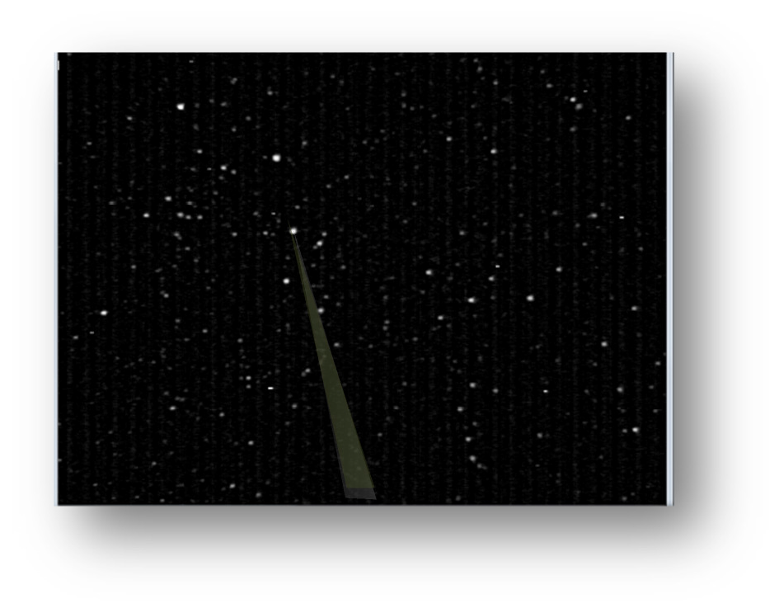

Task 7 - Calibrate the FOV (Manual Calibration).
The field of view (FOV) needs to be calibrated so that there is an accurate record of the RA/DEC and flux for each meteor track. The way this works is that the program compares an image created from averaging actually 256 frames of video with a simulation of the same region of sky that is created from a database of up to 8.5 magnitude stars (C:\CAMS\STARS8TH_VBVRI.txt).
There are four methods for calibration. First is FTP_MeteorCal.exe. The second is FTP_MeteorCal_AutoUpdate.exe. The third is FTP_MeteorCal_NudgeUpdate.exe.
Use FTP_MeteorCal.exe under the following circumstances:
- when you first set up the system
- whenever the camera is moved
- when AutoCal fails
- when you can't obtain a "Mean O-C" under 2.5 with sufficient number of stars (at least 50 stars) with FTP_MeteorCal_Update.exe or FTP_MeteorCal_AutoUpdate.exe, and re-running FTP_MeteorCal_NudgeUpdate.exe several times doesn't improve the numbers.
  - Capture a few frames for you to use for calibration by performing the following step:
    - From a command prompt enter the following commands:

cd \cams
Capture8AndDetect.bat

The program will respond with a text window and a graphic window. After about 36 seconds of capture (0.01 of an hour), it will terminate on its own.
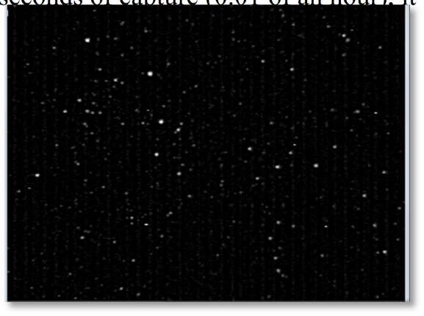

  - Run CamsGUI.exe.
  - Select a CapturedFiles session.
  - Run "Manual Calibration".
  - Enter the target camera to manually calibrate:
<your camera number>
  - Enter the timestamp of the FF you intend to use for calibration (in hhmmss format): [Press [Enter] to skip, [P]review, or [Q]uit]:
Press Enter
  - Press Enter
  - Navigate to and select an FF...bin file that has a star field that you recognize. The FF files will be located in a subdirectory of the “..\CAMS\CapturedFiles” directory. The subdirectory is named with the most recent date/time.
  - Use a planetarium program to locate the center of the FOV (or use the RA/DEC that was calculated for you). Another option is to perform a plate solve using your plate solve software or by converting an FF file to JPG and then uploading that JPG to http://nova.astrometry.net/upload.

Tip: Use a planetarium program, such as StarryNight, TheSky, Cartes du Ciel, etc. to determine the RA/DEC and Alt/Az at the time of day the .bin file was captured.
Cartes du Ciel means "Sky Chart". You can download it for free from:
http://www.ap-i.net/skychart/start
The planetarium program can be adjusted to the same UTC time as the time shown in the video frame. Move the planetarium program to point to the same constellation that you recognize.
If you have previous calibrations that are close enough, you can use the RA/DEC values from those. Another improved method is to use the AutoCams "Manual Calibration". It will prompt you for the time of the FF file you will be using for calibration and calculate your new RA, DEC, and FOV values for you.
  - Enter the FOV width in degrees: 32
  - Enter FOV center Right Ascension (degrees):
(obtain this from the planetarium program and multiply the hour by 15) Example: 22hr 09m is 9/60 + 22 = 22.15. Then multiply that by 15.
22.15 X 15 = 332.25. So, you'd enter 332.25.
  - Enter FOV center Declination (decimal deg):
Example 54.21 for 54 deg 13' 9" (obtain this from the planetarium program)
Example: 13.15/60 + 54 = 54.219
The four calibration windows appear.

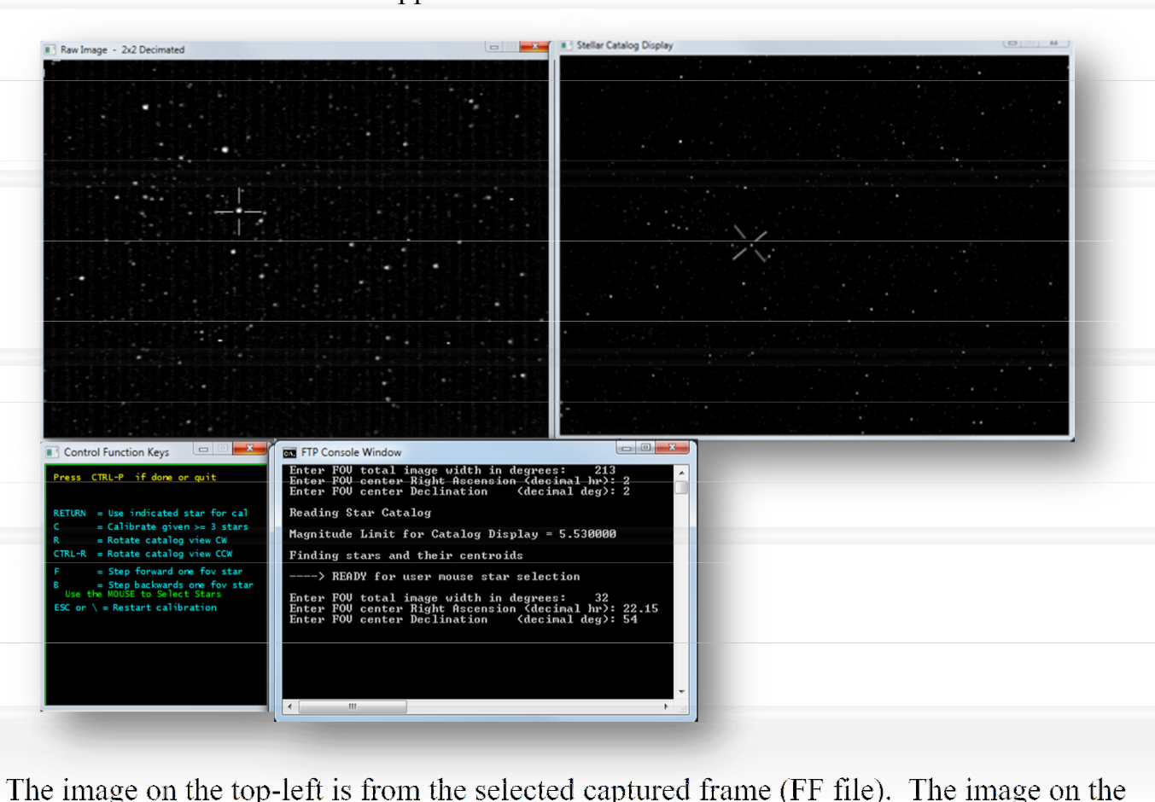

The image on the top-left is from the selected captured frame (FF file). The image on the top- right is produced from a database of stars over 8.5 magnitude. The window on the bottom-left is a window containing some instructions on how to skip forward or backward, to rotate the FOV, etc. The console window on the bottom-right is where you enter values and where it displays feedback during calibration.
The application will usually select a star on the left and right. Very often, it is difficult to match the stars that the application chooses for you. Just ignore that and select the star on the left that you recognize and do that same on the right.
  - Select a star on the right (from a database) that matches a star on the left (from the captured frame).
  - Select the matching star on the left (from the captured frame) and press the RETURN key to accept. Be very careful to select the proper star. Avoid stars that have closely positioned stars adjacent to them. In that case, press F to skip forward to the next star. You can go back by pressing the B key.
  - Repeat until at least 6 stars have been carefully matched/calibrated (try to calibrate the center and the corners first).
  - Once 6 stars are calibrated, the application will facilitate the selection of stars by choosing the star on the right and automatically matching it with the closest star on the left.
  - You should be able to just press RETURN for those that match. However, if you don't see a star on the left in the crosshair, press the F or B keys to move forward/backward to the next choice. You don't want to calibrate on noise, hot pixels, satellites, doubles, or other artifacts. Also, for the first 60-80 or so stars, press F if a star appears very close to another star or too close to the edge.
  - Continue this accurate manual calibration until about 80 stars have been calibrated.
  - At this point, press "C" to Calculate.
  - It will display:

Number of calstars used = 114 0.949523 0.417211 Mean O-C = 0.950 +- 0.417 arcmin
Do another calibration outlier purge (1=Yes,0=No)
  - The key value you are looking for is a "Mean O-C" value of 2.50 or less. If it is greater than or equal to 2.50, press 1 to exclude some of the outlier's (Stars with a less than accurate alignment - very often, these have a larger +- value) and then it will re-calculate and show a new Mean O-C and the number of calstars used. If you can't achieve a Mean O-C of under
2.50 - 0.50 with sufficient number of stars (50, but not less than 35), you will need to re-do the FTP_MeteorCal.exe procedure again and be extra careful to skip doubles, hot pixels, etc. or use a different frame that has better video fidelity or less noise.
  - Once you achieve the best Mean O-C value with about 50-60 stars, press "0", then Ctrl+P to process and save.

You should not need to, but if you want to rotate the database display during calibration you may do so by pressing R or Ctrl+R.
  - It is a good practice to then run an option "Auto Calibration" after a manual FTP_MeteorCal.exe in order to refine the calibration further. Don’t forget to manually delete the manual calibration file from the Cal directory after your auto calibration. A good rule of thumb is to try for 1/10th of a pixel of accuracy or better. Don't use an FF file that is earlier in the night than the one chosen for the manual calibration. When you perform multiple calibrations for the same night, it is a good idea to delete the CAL files from the Cal directory that you don't want to use. Otherwise, the Apply function may choose a less than accurate calibration file. The Apply function tries to use the most recent date/time.

Task 8 - Manual Re-Calibration Example Run:

  - First, you should know about and learn how to use FTP_MeteorCalNudgeUpdate.exe. This program allows you to re-align the stars by moving in +/- RA, +/- DEC, or rotation. It is important to always perform an autocal after using NudgeUpdate.
  - Here is an example of performing a Manual re-calibration using option "Manual Calibration"...
This might be helpful in running a manual cal when autocal fails. Here is a sample output…
- Yellow: What you enter;
- Gray: Something you should read or pay attention to;
- Green: Output that you should pay attention to

call "c:\cam213\CAMS\FTP_MeteorCal.exe" 000213 "c:\cam213\CAMS\Cal"

---------------------------------------------------------
METEORCAL 1.40 - Copyright 2010 Peter S. Gural
---------------------------------------------------------

Opening dialog box to search for FF_000213*.bin files

Enter FOV total image width in degrees: 32
Enter FOV center Right Ascension (decimal deg): 286.9670
Enter FOV center Declination (decimal deg): 63.667

Finding stars and their centroids Reading Star Catalog
Magnitude Limit for Catalog Display = 9.000000

----> READY for user mouse star selection
star mag V = 7.36 B-V = 1.28 R = 6.62 IR = 5.92

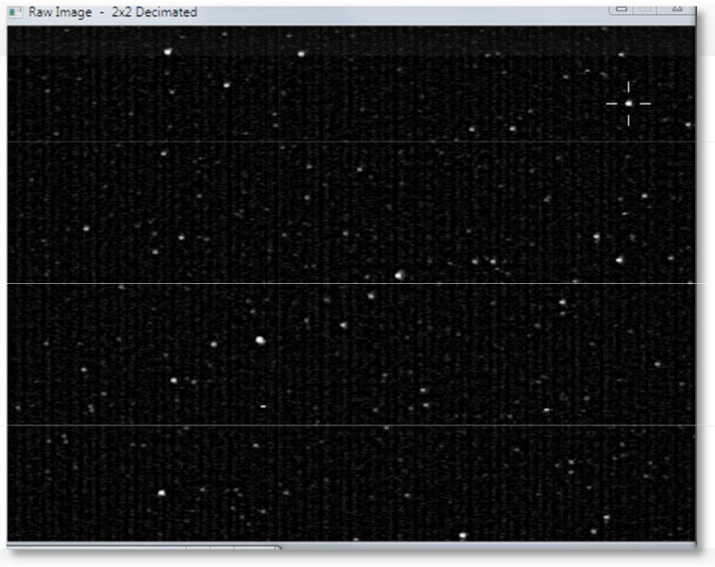
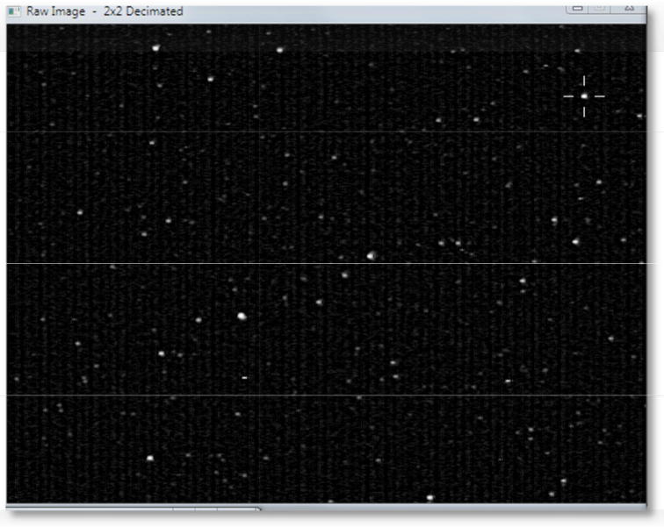

Now you do the manual star matching from right to left, press C when you have a significant number of cal stars matched, and press "1" to discard outliers until the star count gets between 50 and 60. Finally, Press Ctrl+P to complete the calibration and return to the menu.
*********** Star #1 ***********
*********** Star #2 ***********
*********** Star #3 ***********
*********** Star #4 ***********
*********** Star #5 ***********
*********** Star #6 ***********
*********** Star #7 ***********
*********** Star #8 ***********
*********** Star #9 ***********
*********** Star #10 ***********
*********** Star #11 ***********
Etc…
C
Calibration completed ----------------------------

Field of View Size | = | 20.8 X 27.2 deg
FOV center Azimuth | = | 330.3 deg East of North
Elevation | = | 53.7 deg Above Horizon
Plate scale = 2.8 arcmin/pixel Plate Roll wrt Std coords = -117.4 deg
Camera Tilt wrt Horizon = 0.8 deg
FOV center RA | = | 254.14 deg = | 16.94 hr
FOV center Dec | = | 64.32 deg
Cubic calibration completed ----------------------
Field of View Size = 22.1 X 29.6 deg
FOV center Azimuth = 330.3 deg East of North Elevation = 53.7 deg Above Horizon
Plate scale = 2.8 arcmin/pixel Plate Roll wrt Std coords = -117.3 deg
Camera Tilt wrt Horizon = 0.8 deg FOV center RA = 16.94 hr
FOV center Dec = 64.31 deg
1 Xcoef = 8.885037e-017 Ycoef = -4.336809e-017 x Xcoef = -3.677461e-004 Ycoef = 7.123382e-004 y Xcoef = -7.085541e-004 Ycoef = -3.720296e-004 xx Xcoef = -1.158927e-008 Ycoef = 4.430910e-009 xy Xcoef = -9.863902e-009 Ycoef = 1.205106e-009 yy Xcoef = -1.008194e-009 Ycoef = 4.514046e-011
xxx Xcoef = -1.342416e-010 Ycoef = 2.158130e-010 xxy Xcoef = -2.789358e-010 Ycoef = -5.431456e-011 xyy Xcoef = -1.189345e-010 Ycoef = 2.197064e-010 yyy Xcoef = -2.774268e-010 Ycoef = -4.729159e-011
-----
Mean O-C = 2.736 +- 5.244 arcmin
Number of calstars used = 192 1.258318 0.872481 Mean O-C = 1.258 +- 0.872 arcmin
Cam 213 - Do another calibration outlier purge (1=Yes,0=No)

Number of calstars used = Mean O-C = 0.448 +-0.447932 0.183810
 | 58
0. | 18

4 arcmin

Cam 00213 - Do another calibration outlier purge (1=Yes,0=No)
Check Calibration: CTRL-P to ACCEPT
Escape or \ to Start Over
Hit ENTER key to return to main menu

SU | CCESS
 | Be su | re to write down the date/time of the FF file used for calibration.
- call "C:\CAMS\ValidateCal.bat" /cal "C:\CAMS\Cal\CAL_000213_20120605_105631_326.txt"
CAL_000213_20120605_105631_326.txt, [Cal stars=58] O-C=0.448+-0.184 Scale=2.762 [ALT=53.724 AZ=330.345] [RA=254.1820 DEC=64.319]

- Next steps are:
- 1) Run Auto Calibration" to fine tune this manual calibration '
- 2) Run option "Apply Cal to Archived" once you have a good calibration

Task 9 - Setting up the Task Scheduler
Note: The Windows Task scheduler behaves differently on practically every version of Microsoft Windows. The location of the program is even at a different location of almost every different version of Windows.
  - Start the Windows Task Scheduler according to the method on the version of Windows you are using. For example, on Windows 7, you can run the following command from Start > Run:
taskschd.msc /s

In Windows XP, the Task Scheduler is found in Start > Programs > Accessories > System Tools > Scheduled Tasks.

Task 10 - Summary
What is most important is that data is not lost and that it gets transmitted to NASA.

If you don't capture, the project will be missing that data. If you don't successfully perform [meteor] detection, you will get behind and it is difficult to catch up.

  - More information:
FTP_Capture or FTP_CaptureAndDetect or FTP_CaptureTwoAndDetect or FTP_CaptureFourAndDetect or FTP_Capture8andDetect or FTP_Capture16andDetect, can be run by double-clicking on the executable or from a command-line.
When you double-click these executables from Windows Explorer, the program will run in interactive mode, where it will prompt the user to enter the camera number, duration of the capture in hours, and the target location.
If the duration entered is zero, the user is prompted to manually start and stop the capture process. If the duration is greater than zero, the program automatically starts the capture and stops after the designated time has elapsed. If the duration is negative, the program calculates the negative duration value as a sun angle and stops and starts capture based on that sun angle.
Alternatively, if the application is run from a command-line, optional command-line arguments can be provided to parameterize the execution of the program:
FTP_CaptureAndDetect [[[[mode] [camera number]] [duration hours]] [target location]]
Examples:
FTP_CaptureAndDetect
The user is prompted for the camera number, duration, and target location
FTP_CaptureAndDetect 2 000212
The user is prompted for the duration, and target location
FTP_CaptureAndDetect 2 000212 10.5
The user is prompted for the target location
FTP_CaptureAndDetect 2 000212 10.5 "h:"
The program runs with the provided parameters.

FF files means "Flatfield Temporal Pixel Video Capture and Compressed". This is a proprietary video file format designed specifically for the purpose of this application. These video files cannot be viewed using standard viewers. You would need to convert them to another format to be able to review the video - various conversion utilities are provided for this purpose and they will be documented.
A folder is created for saving the FF files based on the date/UTime at the start of the capture. UTime means UTC time.

UTC is kind of the same thing as Greenwich Meantime, but there are significant differences. For the purpose of this discussion, it is the universally coordinated world clock time at longitude zero. UTC is used throughout these applications. Local time (civil time) is calculated as the UTC time added or subtracted from the timezone offset. Pacific Daylight Time is UTC -7 hours and Pacific Standard Time is UTC -8 hours.
The higher level directory is always user-specified and the "\CAMS\CapturedFiles\" is appended to the user-provided [target location]. For example: a capture that starts on Jan 5, 2011 3:11:05 UT and the target location specified was "D:\cams\2011" would have the FF*.bin files placed into the folder "D:\CAMS\CapturedFiles\2011_01_05_03_11_05\".
  - Manually terminating the Capture.
Don't just close the windows or terminate the process unless absolutely necessary. This will cause corrupt FF files and an incomplete/corrupt detect file. Instead, you have two options. One is to pause capture, and the other is to Cancel capture.
    - To Pause Capture, press CTRL+P.
    - To Cancel Capture, press CTRL+P twice. Then wait until all the windows close themselves.

WARNING: If you interrupt capture and then start it again, you will have multiple working directories with the same date. However, the 0.990 release, you can submit multiple capture sessions per night without problem.

Task 11 - Calibrating

In autonomous mode, calibration is automatically performed so there would be no need to perform this task unless the autocal during autonomous mode operation fails.
There are four methods for calibration. First is "Manual Calibration" (uses FTP_MeteorCal.exe). The second is option "Auto Calibration Update" (uses FTP_MeteorCal_AutoUpdate.exe). Option "Nudge Update" is now available (uses
FTP_MeteorCal_NudgeUpdate.exe). Nudge Update is preferable to full manual calibration.

Use option Manual Calibration whenever the camera is moved, or if you can't obtain a "Mean O- C" under 2.5 with sufficient number of stars (at least 50 stars) with Auto Cal. Preferably, the autoupdate will do the job for you.
  - AutoCal
    - Auto calibration iterates through the FF files in the specified directory and performs these steps for each one:
      - Checks the FOV for the star count.
      - If the star count is less than the target number (usually 50 or higher, see CamsGUI.ini > [CALIBRATION] bat_calnstars and bat_starcountthreshold), then it skips to the next file in the list.
      - Otherwise, it checks the Mean O-C value. If the Mean O-C value is greater than the target amount (2.50 or lower, , see CamsGUI.ini > [CALIBRATION] bat_caloc), it will perform an outlier purge until either the star count falls under the target number or it succeeds in achieving the Mean O-C value. If it achieves the target Main O-C value with the target star count, then it logs those values and moves on to the next FF file in the list. When it completes the list of FF files, it creates a CAL file in the C:\CAMS\Cal directory based on the FF file that produced the best calibration values.
Autocal produces a file, named AutoCalUpdate.log in the source directory (CapturedFiles). In the case where autocal fails, you can examine the log to determine possibly the best file to use for a manual calibration. The file listed in the log with the highest number of stars and a lower Mean O-C value would be a good choice.
  - Manual Calibration

Task 12 - Apply Calibration to Detect File

In autonomous mode, this task is unnecessary unless there is an error and the calibration has to be performed manually.
The meteor detection routines work like this. When it finds a possible meteor, it records the event information into the "detect file". For each event, the FF file and its CAL file are listed in the detect file. The X/Y pixels and RA/DEC coordinates of the event are recorded in the section for that event. The meteor detection routine uses the most recent CAL file available, which might be from a date previous to the one it is processing. Therefore, it becomes necessary to patch the detect file with the new calibration file after calibration. At the same time, the RA/DEC coordinate values of each event need to be skewed by the difference between the calibrations as well as magnitude information. The "Apply Cal to Archived" and "Apply Cal to Confirmed" options do this job (uses the FTP_ApplyCal2detectinfo.exe program).

Note: This script should soon change its behavior in the following manner:
- Before calling the FTP_ApplyCal2detectinfo.exe program, it will rename all the CAL files in the Cal directory (except the latest created for that date) to something that will not be visible to the .exe program. This is to avoid the confusing mess of what happens when there are Cal files that are based on a newer FF file than an AutoCal-generated cal file. This renaming function will apply to all Cal files except the latest file generated for the date in question.
- Whether Apply succeeds or fails, the files will be renamed back.
  - When you run the Apply Cal to Archived option, it starts and prompts you for some input…
  - Then answer the prompts.
It is imperative that the correct CAL file is applied to the detect file. One good test is to open the detect file with Notepad and check if the CAL file listed for each event is the expected CAL file for the date in question. If it is not, you will need to correct the reason why it is not working and try again.
In interactive mode (when you're not using the CamsGUI menu to launch it), the program produces an FTPdetectinfoC.txt file in the target directory. You will need to use that C file to validate that the program functioned as expected and then delete the original. Here is a command that will do that for you:

move /y ftpdetectinfoC.txt FTPdetectinfo.txt
  - Calibration Troubleshooting:
Sometimes, there are troubles with calibration. A bad calibration one night will affect all subsequent nights. If you find that a night, or several nights in a row, are not processing properly, check the calibration files starting with the night before they seem to start going bad. You can rename all subsequent nights to something like "xCAL_000299_*.txt" and then run the AutoCal" option again. Or manually calibrate that oldest bad date. You should be able to autocal after that... at least for the clear nights. Overcast and partly overcast nights also produce problems.

Task 13 - Confirming (optional)
The Confirmation step is optional. However, if you get a chance to run it, it will give you an idea of the level of activity each night. If you perform the confirmation process meticulously enough, you can submit the detect file from the ConfirmedFiles directory instead of from the ArchivedFiles directory. In that case, the ConfirmedFiles subdirectories are usually much smaller.
If you have moved the files to another drive, the detect file will need to be patched so that the FF folder and the CAL folder entries reflect the new location. You can use the FixDetectPaths.bat script to make those changes for you.
  - It may be necessary to use the "Move SubmissionFiles dirs to working files dirs" option prior to performing the confirmation step. To undo the submission, choose the “Move to Working directories” option.
  - From the CamsGUI menu, select option "Confirmation". It will use the target location, camera, and captured date to create command line arguments when launching the program. If you run it in interactive mode, you will need to follow the prompts and navigate to and select the FTPdetectinfo.txt file.
  - It will display your image on the left and a console window on the right. The Console window needs to have the keyboard focus when entering in commands. If you see an event that appears to be a meteor, then press Enter to "accept". You need to error on the side of false-positives. False-positives are OK. When in doubt, accept.
  - Reject by pressing any other key.
  - You can go back as many as 15 events and re-enter your accept/reject decision.
  - You can press "f" to skip to the next FF file. Just remember that it will only be able go back no more than 15 events.

Task 14 - Transmitting
This task is performed by either running the “Cams2 Upload Queue” schedule task. You can right-click on it and then select “Run” from the task scheduler or run the “upload_queue_START.bat” script from the “..\cams2_queue\RunFolder”.

Task 15 - Archiving
See the “CAMS Storage Management.pdf” document for an explanation of the 3-tier storage management proposals for CAMS.
Archiving is a key element of management of files and storage in any CAMS system. Each camera will produce about 6 GB of data per night.
The system is designed to run CAMS in its working directories. The SubmissionFiles directory is a form of Tier-2 storage, which is out-of-line with the main workflow. Files are migrated out of the SubmissionFiles when they age to a predefined level. Less useful data is culled. Some of the data is transmitted to the NASA server (where coincidence processing is done), but this is an extremely small subset of the data. If it is discovered that the data has to be reworked, then you can restore it from the SubmissionFiles or from the cams_Archive zip files. There is a paper that describes the intricacies of the CAMS Archving system that you should at least be somewhat familiar with.
There is a CAMS project policy to purge archive zip files that are in their 3rd year of storage. If you desire to preserve those files, it will be up to the site operator to back them up onto DVD or some permanent non-volitile storage (Tier-3).

Task 16 - Calibration Tricks
This section provides some tips and tricks to facilitate manual calibration. A couple of things to note...
The Cal center Dec (deg), Cal center Azim (deg), and Cal center Elev (deg) values shouldn't change from night to night very much. If a calibration produces results where these values change more than a degree, it is an indication that it is either a bad calibration or the camera has moved. If the camera has moved, a manual calibration will be necessary. How can you tell which method to use? Examine a calibration file for another clear night after the night in question. If the values haven't changed, then it is a bad calibration. If the values have changed, the camera may have moved. If you delete the CAL file for the night in question, then run autocal for the subsequent night, if that produces a CAL file with these values the same, the night in question has a bad cal and you need to resolve that before transmitting it.
Important: After performing a manual calibration, it is always a good idea to fine-tune that manual calibration with a calibration update, either autocal or just cal update.

Tip: The RA drifts by approximately 1 degree per day when you consider there are 360 degrees in a circle and 365 days in a year.
  - First, check if you have a valid cal file for that camera in the current position. You can open that cal file and use the RA and DEC values as a starting point.

    - In the example above, you'd want to write down the following information:
• File name: CAL_000213_20120530_105148_548.txt
• RA=247.3660
• DEC=64.505
• ALT=53.751
• AZ=330.717
Note: The date/time in the cal file name in the above example is: 05/30/2012 at 10:51:48.548 UTC.
Also, it is a good idea to monitor the ALT/AZ values from time to time to see if there is any migration in the mount over time. These are you best indicators if the camera has moved.
    - See Manual Re-Calibration Example Run: above.
  - Determine which FF file (either from the ArchivedFiles or CapturedFiles directory) that you will be using for a manual calibration. This will be called the "FF file used for calibration".
    - One method of determining this is to perform the autocal function and watch for frames that have a sufficient number of visible stars. Write down the time section of the good file names.
  - Another trick is to examine the AutoCalUpdate.log file from the autocal pass. You should be able to locate this under the CapturedFiles directory. The log file will list all the files that it examined. You could start your manual Cal using the file name in the log that shows the highest number of stars with the lower value for Mean O-C.
  - Open the most recent calibration file in the C:\Cal directory whose date is the closest date to the date that you're calibrating.
    - Near the top of the file, you will find the following entries, along with their values, that will be useful for this task:
Calibration date
Calibration time (UT)
Cal center RA (deg)
Cal center Dec (deg)
Cal center Azim (deg)
Cal center Elev (deg)
    - Calculate the time difference (in hours) between the FF file used for calibration and the time of the calibration file. Note: AutoCams option 7d performs this calculation for you.
      - Example: The FF file used for calibration is FF299_20120209_103741_704_0871680.bin and the recent calibration file was CAL299_20120208_022447_641.txt.
      - Convert the times to decimal hours. This is done by dividing the minutes by 60, then adding the hours:
"103741" = (37/60)+10=10.617
"022447" = ((24/60)+2=2.4 (no need to be accurate to the second)
      - Then subtract 10.617 - 2.4 = 8.217 hours difference.
      - To convert the difference in hours to a difference in degrees, multiply the hours by 15:
8.217 * 15 = 123.255
      - Add this to the RA value in the previous calibration file.
      - Add to the RA value the number of days between the old date and the new date.
      - If the result is greater than or equal to 360, subtract 360 from the result:
194.717 + 123.255 + 1= 318.972
or another example might be:
254.652 + 123.255 + 1= 378.907 - 360 = 18.907
      - Use the result in the manual calibration as the RA (deg) value. Use the same Dec value in the previous calibration file's Dec (deg) value in the manual calibration.
  - If the camera may have moved and you can't attain a valid calibration update or autocal nudge update using a good clear star field, you need to determine new values for both RA and Dec.
    - Use autocal to iterate through the FF files to view them until you recognize a star pattern that you can find in a planetarium program (such as Starry Night or Cartes du Ciel, etc). This will be referred to as the "FF file used for calibration".
    - Use the planetarium program and adjust the FOV to about 32 degrees.
      - Adjust the Lat/Long to your position.
      - Adjust the date/time to the date/time of your FF file to use for calibration. Be sure to adjust for Universal Time.
      - Set the orientation to terrestrial view (which puts the horizon down and the zenith up).
      - Move the view until the Alt/AZ approximately matches the Alt/AZ of the camera position.
      - Move the view a little more until you see stars the match the FOV of the FF file to use for calibration.
      - Obtain the RA/Dec and Alt/AZ from the Planetarium program.
    - Convert the RA value to degrees, if necessary, by multiplying by 15. For example:
RA 14h 32m 48.2s
((32/60) + 14 ) * 15 = 218.25 degrees
    - The Dec value does not need to be converted.
    - Use those values when entering in the RA and DEC values into the manual calibration program.

Task 17 - Coincidence
This section will describe some useful information about coincidence processing so that you have a better idea of some cool stuff that happens with your data. Coincidence processing is when the meteors from different sites are triangulated and orbits and other information is calculated.
      - CAMS_nnnnn_HeightVsRange.jpg
(Bottom-left Height(km) versus Downrange(km) window)

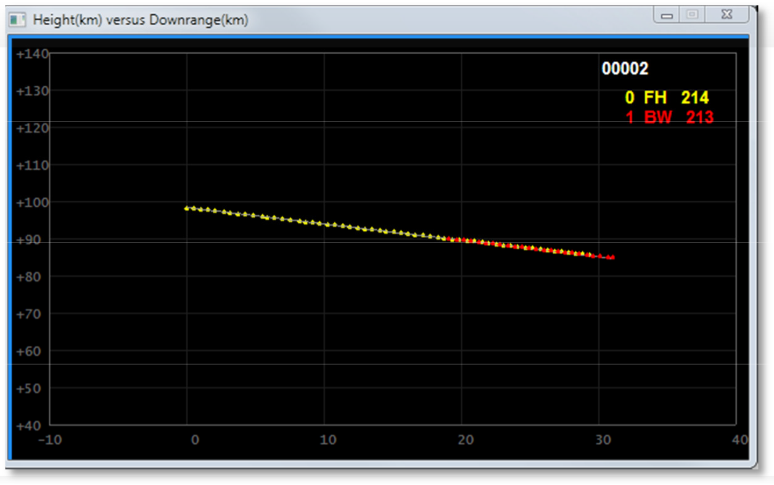

The ideal result is two overlapping lines. In this example, you have camera 0 FH that tracked this meteor from 99km to about 85km height for 30km. Camera 1 BW tracked this meteor from 92km to 84km for about 14km downrange.
      - CAMS_nnnnn_LatLong.jpg
      - (Top-right Ground Track Offset(km) re Track Center Latitude & Longitude window)

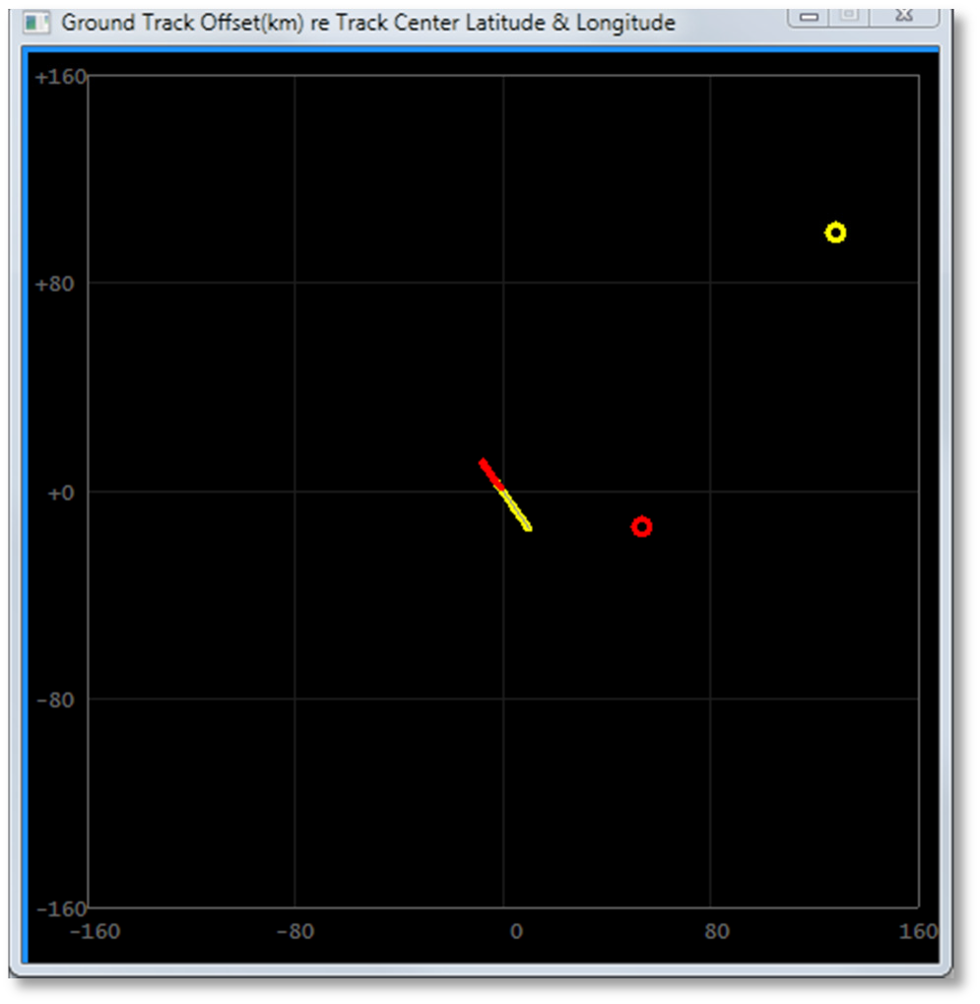
The ideal result shows two overlapping lines that follow the same ground track. There is a possibility that one camera's track of the meteor doesn't actually overlap with another camera. However, the fact that they share the same linear path over the ground track "may" indicate that it was the same meteor. In those cases, you need to use a bit of care and remember that (a) a meteor with a long ground track probably needs to have a higher intensity at some point than shorter lived meteors; (b) Because there is not overlap, you may have to discard this coincidence.
      - CAMS_nnnnn_MagVsHeight.jpg
      - (Top-left Magnitude versus Height(km) window)

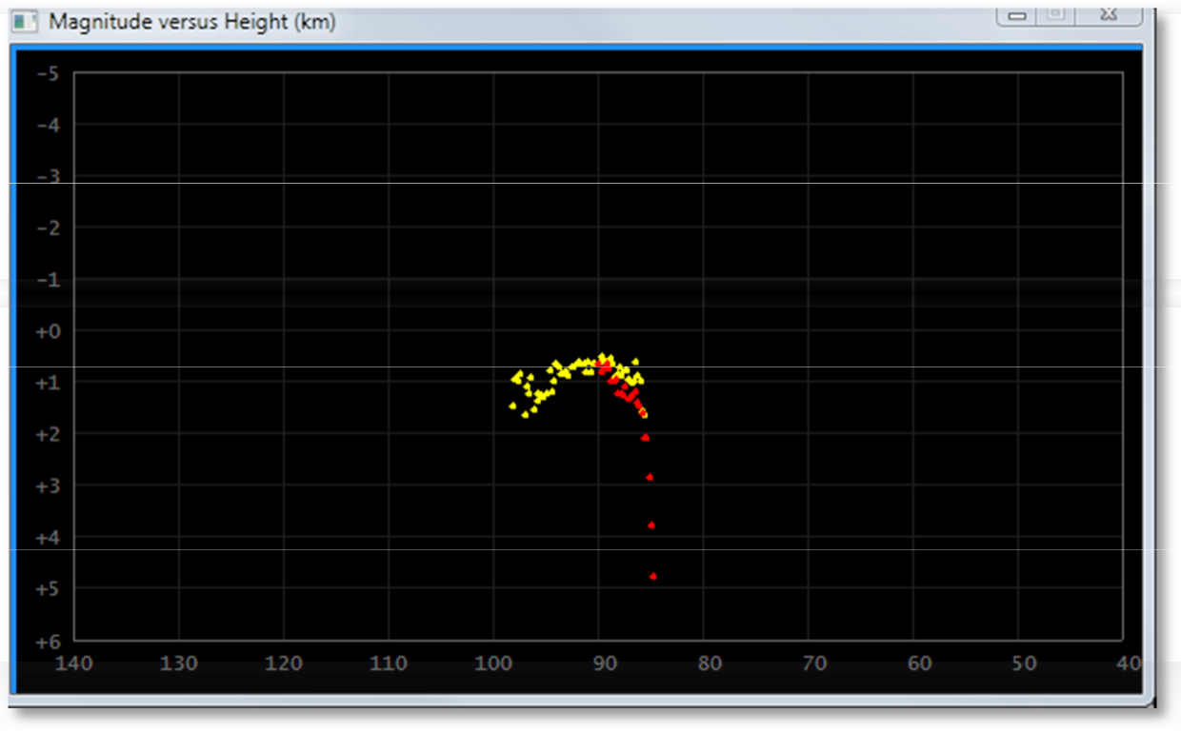
The magnitude is corrected for distance. Ideally, you will see a rise in magnitude and then a drop in magnitude. The height in km allows you to see where the altitude of where it all occurred.

Task 18 - Archiving for DVD with the Pre-DVD Archive utility.

WARNING: The previous batch script "MakeArchiveDateZip.bat" is obsolete and it has not been tested. Do not use that script anymore.
Archiving to DVD or other non-volatile storage is much simpler that it was in the past. Now, you only have to copy the files from the cams_Archive directory. It is good to remember how much storage your permanent storage contains and select your files to backup according to the settings in the [CAMS2ARCHIVE] section. See:
The new archiving routines will automatically purge the archive drive of all files that are older than the number of years specified in the Cams2Global.ini file MaxYears

// MaxYears_archived_... means the maximum number of years to keep the archive
// before purging the archive. For example, the default setting is 2 years. That means, that in
// January 2020, we keep archived SubmissionFiles for 2019 and 2020 but we delete/purge the
// archived SubmissionFiles for 2018 and earlier.
//
MaxYears_archived_SubmissionFiles=2
MaxYears_archived_TransmittedFiles=2

You will end up with a zip file for each directory under the SubmissionFiles directory. You can move those .zip files to the DVD burner or BluRay (The size of the standard -R DVD format).
IMPORTANT: Always use DVD -R discs or rewritable BluRay. Do not send discs in +R or +-R, or RW format.

Once you enter a date or select a CapturedFiles directory from the list, it will attempt to read the associated directories scanning for the number of files, detection files, etc. In many cases it will tell you "File Not Found - No CapturedFiles directories found matching yyyy_mm_dd". It will do the same for the ArchivedFiles directory. Ignore this if it happens.
Eventually, the AutoCams menu will appear.

Task 19 - "AutoCams.Params.ini" file settings
This section will describe the possible settings for the "AutoCams.Params.ini" file. When the scripts read this file, each key/value pair makes a new environment variable in the following format:
bat_SECTION.key=value
If the key name within a section begins with "bat_", the created environment variable matches exactly to the key name. In the following example, the two variables created would be:
bat_CAPTURE.capture_mode=capturetwoanddetect bat_captureexe=FTP_CaptureTwoAndDetect.exe

[CAPTURE]
capture_mode=capturetwoanddetect bat_captureexe=FTP_CaptureTwoAndDetect.exe

Note: The scripts ignore any of the following conditions: Blank lines
Any line that has a space as the first character Any line that has a TAB as the first character Any line that has "//" as the first two characters Any line that has "rem" as the first three characters Any line that has "rem " as the first four characters
    - [AUTOCAMS] section is for parameters that govern the AutoCams functions.
      - bat_vers=1.00a [OBSOLETE]
This is where the AutoCams menu gets its version information when it displays it.

      - autonomouslevel=apply [OBSOLETE]
Governs the level of autonomous operation. This setting indicates the last step that you want it to perform. Possible options are (default is "apply") (Use only one of the following):
autonomouslevel=cal autonomouslevel=apply autonomouslevel=applyconfirmed autonomouslevel=submit autonomouslevel=zip autonomouslevel=ftp

      - completewait=5 [OBSOLETE]
Number of seconds to wait after autonomous mode processing. The delay allows a user to allow the unattended autonomous mode to system to delay for a longer period in order to catch and review the console before it kills the window.
      - diskspacewarning.days=14
Number of days to use in calculating whether you are going to run out of disk space with that timeframe.
      - diskspacewarning.hour.per.night = 14
Maximum number of hours per night on the longest night. This value is used in calculating whether you're going to run out of disk space within the number of days specified in diskspacewarning.days.
    - [CAPTURE] section governs parameters used during capture.
There are essentially three modes of capture: Capture single camera, Capture single camera while simultaneously performing detect, Capture two cameras while simultaneously performing detect.
The "CaptureTwoAndDetect" mode has the option of capturing two cameras but disabling detect. Use that mode when you find that excessive number of frames are being dropped during capture and detect but the number of dropped frames is acceptable when disabling simultaneous detection.
The "capture_mode" settings are configured by using multiple variables together, namely:
- capture_mode
- bat_CD_flag and archive_flag
- bat_captureexesrc
- bat_captureexe
- bat_capturebat
- cameralist
      - Use one of these configurations (note, two are commented in the default file): [OBSOLETE]
        - For Single camera with no background detection. Note, you will need to use AutoCams options 44 and 44b to complete the detect process after capture completes.

[CAPTURE]
//===== Single camera, no background detection ===============
//capture_mode=capture
//number.of.cameras=1
//cameralist=998
//archive_flag=-1
//bat_capturebat=CaptureTwoAndDetect.bat
//bat_captureexe=FTP_Capture_998.exe
//bat_captureexesrc=FTP_Capture.exe
//~~~~~~~~~~~~~~~~~~~~~~~~~~~~~~~~~~~~~~~~~~~~~~~~~~~~~~~~~~~~
        - For Single camera WITH background detection. Note, you may need to use AutoCams options 44 and 44b to complete the detect process if capture is interrupted (for example, the computer reboots in the middle of the night).

[CAPTURE]
//===== Single camera with background detection ==============
//capture_mode=captureanddetect
//number.of.cameras=1
//cameralist=213
//archive_flag=-1
//archive_flag=2
//bat_capturebat=CaptureTwoAndDetect.bat
//bat_captureexe=FTP_CaptureAndDetect_998.exe
//bat_captureexesrc=FTP_CaptureAndDetect.exe//~~~~~~~~~~~~~~~~~~~~~~~~~~~~~~~~~~~~~~~~~~~~~~~~~~~~~~~~
~~~~
        - For Dual cameras WITH or WITHOUT background detection. Note, you will need to use AutoCams options 44 and 44b to complete the detect process if capture is interrupted (for example, the computer reboots in the middle of the night). To disable background detection, use a value of -1 for the archive_flag.

[CAPTURE]
//===== Dual camera with/without background detection ======== capture_mode=capturetwoanddetect
number.of.cameras=2 cameralist=998 999 archive_flag=2
// -1 = Don't perform realtime background detection (for slow systems that can dual capture but not detect)
// 0 = Leave FF files in CapturedFiles dir
// 1 = Copy FF files from CapturedFiles to ArchivedFiles dir (takes extra I/O + CPU)
// 2 = (default) Move FF files from CapturedFiles to ArchivedFiles after completion bat_capturebat=CaptureTwoAndDetect.bat
bat_captureexe=FTP_CaptureTwoAndDetect.exe bat_captureexesrc=FTP_CaptureTwoAndDetect.exe
//~~~~~~~~~~~~~~~~~~~~~~~~~~~~~~~~~~~~~~~~~~~~~~~~~~~~~~~~~~~~
        - capture_mode - is a flag used to signal a collection of settings, or a "mode" of operation.
        - number.of.cameras - the number of cameras you will be using

        - cameralist - specifies either one or two camera numbers. The FF*.bin files will be encoded with the camera number matching the camera device used for that 256 frame set.
        - archive_flag - This flag is used by background detection. For performance reasons, there are three modes for background detection. However, the scripts are only compatible with the mode that moves the FF files from CapturedFiles to ArchivedFiles after completion. The other way this flag is used is by using -1 to signal to disable background detection.
        - bat_capturebat - specifies the name of the batch script file that will be chained to from LaunchCapture.bat. I know it sounds strange, but CaptureTwoAndDetect.bat is the latest version of the capture scripts and it has all the logic for the CaptureAndDetect and CaptureTwoAndDetect use-cases. Therefore, use CaptureTwoAndDetect.bat for both of those cases.
        - bat_captureexe - specifies the name of the executable that runs. It is also the name of the executable that is terminated before a new capture session is started. The idea behind this setting was to allow multiple instances of capture to run at the same time. Essentially, a copy of the executable (bearing the camera number) is run instead of the normal executable. This allows you to monitor it using Task Manager. More importantly, if one camera fails and the other continues OK, you can ensure that the failed camera's process is terminated (using process.exe) before the capture for that camera is started again. For dual-camera mode, this is ignored and the bat_captureexe and the bat_captureexesrc values should be the same.
        - bat_captureexesrc - specifies the source name of the executable. The script copies this file to the bat_captureexe file.
      - waitdelay - Either wait or no wait (without quotes). When this setting is set to wait, LaunchCapture will wait until the scheduled Camera ON time. If it is set to no wait, the wait will be ignored and it will move to the capture functions immediately.
    - [CALIBRATION] section is for the calibration scripts.
      - bat_calnstars=50
Minimum number of calstars for "7b. AutoCal" processing. Note: "7c. AutoCal w/ Prompts" still allows you to enter your own values, but it will default to these for the default.
      - bat_caloc=2.50
Minimum number for acceptable "Mean O-C" results. If this value is not achieved, then the script reports a failure and aborts.
      - bat_starcountthreshold=50
Used by ValidateCal.bat for reporting bad calibration files from the Cal directory. (See option "36. Validate Calibration".
      - displaycalstars=false
Not Implemented
If true, during calibration, it will plot the simulated image of the calibration stars as distributed across the FOV. Each will have the x, y residual displayed next to the star.
    - [STAGE] [OBSOLETE] section is for parameters that govern how the "13. Package Working dirs into SubmissionFiles dirs" functions.
      - validatewait=3
Number of seconds to wait after StageFromConfirmed.bat performs the validation and displays the "Total Validation Errors"
    - [COINCIDENCE] section is for the coincidence program parameters. [OBSOLETE]
      - max.height=249
Number of kilometers for the maximum height display
      - min.height=40
Number of kilometers for the minimum height display
    - [DETECT] section is for the coincidence program parameters. [OBSOLETE]
      - maxdetectionthreads=4
Maximum number of detection threads. For systems with fewer than 8 CPUs, you can leave this set to 6. For those with 8 CPUs or more, it may produce diminishing returns to have too many detection threads running at the same time. You should know that the threads start 10 seconds after each other. This is to ensure that subsequent threads don't interfere with previous threads fully operating. An 8 CPU system can be set to 8, but it is probably not necessary. Setting this to 6 allows an 8 CPU system to have free cycles to perform other operations.
    - [SIMULATION] section governs settings used for simulation. I use these settings for daytime testing so it simulates capture, detection, and ftp. Simulation mode provides the ability to store some directories to use as a source in lieu of capturing with a camera, detecting with Capture and Detect or MakeCaseListing. [OBSOLETE]
      - enabled - When set to true, capture and detect is simulated by using the settings in the [SIMULATION] section. Otherwise, simulation is disabled.
      - capture - When set to true, capture and detection are both simulated by using the settings in the [SIMULATION] section.
      - ftp - If true, the FTP simulation is performed instead of a real FTP upload. Otherwise, the real FTP is performed. This setting only applies when simulation is enabled. The reason for this setting was to keep from uploading too many test files to the FTP server.
      - captureddate - Specifies the simulation captured date (simulates AutoCams option 3).
        - CapturedFilesDir - Specifies the directory to which the FF*.bin files are copied from the CapturedFilesSimSource directory in order to simulate capture. (simulates AutoCams option 4)
        - ArchivedFilesDir - Specifies the directory to which the detection files are copied from the ArchivedFilesSimSource directory in order to simulate detection. (simulates AutoCams option 5).
        - SubmittedDir - Specifies the directory used for the Submitted directory.
        - SubmissionFilesDir - Specifies the directory used for the SubmissionFiles directory.
        - CapturedFilesSimSource - Specifies the source directory for simulating capturing to FF*.bin files.
        - ArchivedFilesSimSource - Specifies the source directory for simulating detection.
        - ConfirmedFilesSimSource - Specifies the source directory for simulating confirmed detections.
        - detectfile - Specifies the FTPdetectinfo_*.txt file to be used for this simulation in the ArchivedFiles dir.
    - Here is a look at the file on my dual camera machine...

[AUTOCAMS]
bat_vers=1.00a
//autonomouslevel=cal autonomouslevel=apply
//autonomouslevel=applyconfirmed
//autonomouslevel=submit
//autonomouslevel=zip
//autonomouslevel=ftp completewait=5 diskspacewarning.days=14 diskspacewarning.hours.per.night=14

[CAPTURE]
simulation=false waitdelay=wait
//waitdelay=no wait diskspacewarning=3

//===== Single camera, no background detection ===============
//capture_mode=capture
//number.of.cameras=1
//cameralist=998
//archive_flag=-1
//bat_capturebat=CaptureTwoAndDetect.bat
//bat_captureexe=FTP_Capture_998.exe
//bat_captureexesrc=FTP_Capture.exe
//~~~~~~~~~~~~~~~~~~~~~~~~~~~~~~~~~~~~~~~~~~~~~~~~~~~~~~~~~~~~

//===== Single camera with background detection ============== capture_mode=captureanddetect
cameralist=998 archive_flag=2
bat_capturebat=CaptureTwoAndDetect.bat bat_captureexe=FTP_CaptureAndDetect_998.exe bat_captureexesrc=FTP_CaptureAndDetect.exe
//~~~~~~~~~~~~~~~~~~~~~~~~~~~~~~~~~~~~~~~~~~~~~~~~~~~~~~~~~~~~

//===== Dual camera with/without background detection ======== capture_mode=capturetwoanddetect
number.of.cameras=2 cameralist=998 999 archive_flag=2
// -1 = Don't perform realtime background detection (for slow systems that can dual capture but not detect)
// 0 = Leave FF files in CapturedFiles dir
// 1 = Copy FF files from CapturedFiles to ArchivedFiles dir (takes extra I/O + CPU)
// 2 = (default) Move FF files from CapturedFiles to ArchivedFiles after completion bat_capturebat=CaptureTwoAndDetect.bat
bat_captureexe=FTP_CaptureTwoAndDetect.exe bat_captureexesrc=FTP_CaptureTwoAndDetect.exe
//~~~~~~~~~~~~~~~~~~~~~~~~~~~~~~~~~~~~~~~~~~~~~~~~~~~~~~~~~~~~

[DETECT]
maxdetectionthreads=6

[CALIBRATION]
bat_calnstars=50 bat_caloc=2.50 bat_starcountthreshold=50 displaycalstars=false

[STAGE]
validatewait=3

[COINCIDENCE]
max.height=249 min.height=40

[SIMULATION]
enabled=true capture=true ftp=true
captureddate=2012_08_11 CapturedFilesDir=c:\CAMS\CapturedFiles\2012_08_11_03_44_55 ArchivedFilesDir=c:\CAMS\ArchivedFiles\2012_08_11_08_30_39 SubmittedDir=C:\CAMS\Submitted\2012_08_11_998_03_44_55 SubmissionFilesDir=c:\CAMS\SubmissionFiles\2012_08_11_998_03_44_55 CapturedFilesSimSource=c:\2012_08_11_capture\2012_08_11_03_44_55 ArchivedFilesSimSource=c:\2012_08_11_archive\2012_08_11_08_30_39

detectfile=FTPdetectinfo_09980999_2012_08_11
08_30_39.txt

Task 20 - Focusing Tips and Tricks.
There are a few tricks that can be used to aid in focusing these cameras.
The first tip is to try as best you can to focus and adjust the camera – and test it – as much as possible before installing it in its final location. There are several camera boxes installed on rooftops, on top of poles, and other locations. The bottom line is that the cameras will be outside and the monitor to use for focusing and testing is usually too far away after final installation to perform these functions easily. You may not get it perfect, but at least it will be close enough to only require quick and minor tweaks.
Note: As of 2013, the CameraLiveViewer program shows a focusing aid at the bottom. Camera8LiveViewer and Capture8LiveViewer may not have the focusing aid.
Note: As of 2018, CameraLiveViewer.exe was changed to Capture8LiveViewer.exe. It is not clear why.
  - First, be sure that the distance from the back of the lens to the chip is 17.526mm (0.6900 in).
  - Set the focus to just under infinity and attempt to focus on a star or distant object on the far horizon. 1 C-CS mount adapters and spacer rings. There should be a 5mm C-CS adapter ring.
  - Use the matching Camera*LiveViewer.exe programs to focus. If you are using a Sensoray capture board, then provide the Sensoray812_config.txt file.
  - If you are using a Sensoray capture board, then you can change the full-resolution image by doing the following:
    - Set focus on the “CameraLiveView Console Window” window.
    - Then, using the number keypad, press any of the number keys to advance to the next camera. You will see the Video Camera Mosaic view change from one camera to the next. It cycles through from last to first. 1
  - Turn up the gain to AGC HI during focusing. Don't forget to put it back to the normal setting after focusing.
  - Try to get the focus close using a visual approach.
  - Be careful with daytime focusing techniques if you have an autoiris lens because if the autoiris constricts, it will increase the depth of field and you might not be in focus at night time with a shallower depth of field when the iris is fully open.
  - Hartmann Mask or Batanov Mask focusing
    - Construct a Hartmann Mask or Batanov mask or some other focusing aide to obtain a more objective focus.
    - I don't like either of these because they block so much light and you still can't get a decent focus because they are not good for the last little bit of fine focus adjustments. You might only be able to use a Hartmann mask on something like the moon.
  - Diffraction Spike Focusing
    - This is a focusing aide that you can probably only use on very bright stars.
    - Tape some dental floss across the lens to make a cross.
    - Aim the camera at a bright star or planet. On high gain, it should produce 4 diffraction spikes that look like a crosshair for each bright star that is in focus.
    - If the star is out of focus, you will see 8 diffraction spikes (or double vision of the 4 diffraction spikes from a properly focused star).
    - When you get closer to being in focus, the objective determination for best focus is when:
      - The diffraction spikes are the longest
      - The diffraction spikes begin to show some striping
      - The number of stars in the FOV is highest
  - Software assisted focusing:
    - One program that I'm aware of, K3CCDTools, has a focusing aide. It's $35 for the software. It has not been maintained for the last few years, but you may be able to get it to work on your computer. There is a 30 day trial period (it might be 60 days). The problem is, it might not work on Windows 7 (32 bit or 64 bit). You can go to (http://www.pk3.org/Astro/index.htm) and download it to see if it works. There may be some tricks that you have to use to get it to work with Windows 7. It works fine with Windows XP. It has a focusing dialog that should help with the focusing. ImagesPlus and other software that you have may also help to achieve an objective focus instead of relying on subjective methods.
      - Use WDM interface in preview mode, which provides very fast preview. I recommend to use 10fps, which is fast enough while it retains good picture quality for focusing
      - Use Zoom 200% in Video Capture mode for detailed focusing (requires faster computer)
      - Use Brightness Level Meter with unsaturated star for measuring star's peek brightness. I recommend to use Low pass filter to reduce effect of scintillation (seeing variations).
      - Read more in Help - Chapter 3.8 Video Capture – Brightness Level Meter.
      - Use FFT Dialog for surface objects and watch quality graph in the middle part of dialog. The higher the number shown in the graph the better is focus. The focused object must be in the center of the screen.
  - Green Laser focusing:
    - I have not tried this, but someone suggested pointing a green laser at a distant wall and focusing using that. I imagine that this can be done during the daytime.

Task 21 - Non-menu-based scripts.
  - 7unzip.bat
  - 7za.bat
  - 7zip.bat
  - ApplyCal.bat
  - autocams.setup.bat
  - CaptureTwoAndDetect.bat
  - clear_bat_vars.bat
  - CoincidenceUpload.bat
  - concat.detectfiles.bat
  - CopyFromDetectFiles.bat
  - CreateCalFileList.bat
  - CreateCameraListFile.bat
  - DayOfWeek.bat
  - FTPdailyDownload.bat
  - GetArchivedDir.bat
  - GetCalfileInfo.bat
  - GetCameraList.bat
  - GetDetectFile.bat
  - GetLinesOfCode.bat
  - indent_setup.bat
indent_echo.bat indent_echolog.bat indent_log.bat indent_logexec.bat indent_logexeclog.bat indent_pause.bat indent_pop.bat indent_popecho.bat indent_poplog.bat indent_push.bat indent_pushecho.bat indent_pushlog.bat indent_return.bat
  - KillWait.bat
  - MakeArchiveDateZip.bat
  - MakeCaseListingTrack.bat
  - md5build.bat
md5check.bat md5checkRepeatDirs.bat
  - Move.Archived.bat
  - Move.Submit.bat
  - ParseDir.bat
  - ProessCaptureReturnCode.bat
  - ReadINI.bat
  - ReadParams.bat
  - ReCalibrate.bat
  - RedirectLogs.bat
  - redo.autonomous.bat
  - reprocess_multi.bat
  - rerun_makeCaseListing.bat
  - robocopy.bat
  - show_bat_vars.bat
  - simulationSetup.bat
  - startup_cams.bat
  - StripHeader.bat
  - StripHeaderNASA.bat
  - StripHeaderVBS.bat
  - StripZeros.bat
  - str_math.bat
  - submission.emai..bat
  - synchtime.bat
  - WindowsVers.bat
  - ZipDir_7sa.bat
  - _convertFtpDetectinfo_scanned_to_camera.bat

Supporting Executables:
  - 7za.exe
  - CosmicRayFourChannel.exe
  - md5.exe
  - OrbitCalculator.exe
  - Process.exe
  - ReplaceText.exe
  - robocopy.exe
  - SP_Prescreen.exe
  - vcredist_x86.exe
  - wait.exe
  - WaitFileComplete.exe
  - WaitForFile.exe

Note: More scripts have been added.

- Task 22 - Force AutoCams2 to retry upload of submission
  - If the file has been uploaded already, delete it and its corresponding .md5 file from the Transmitted dir.
  - Then rerun Cams2 Upload Queue scheduled task.

- Task 23 - SPFF_SingleFileViewer.exe
The SPFF_SingleFileViewer.exe program allows you to preview a single FF file at a time. The program has 5 windows.

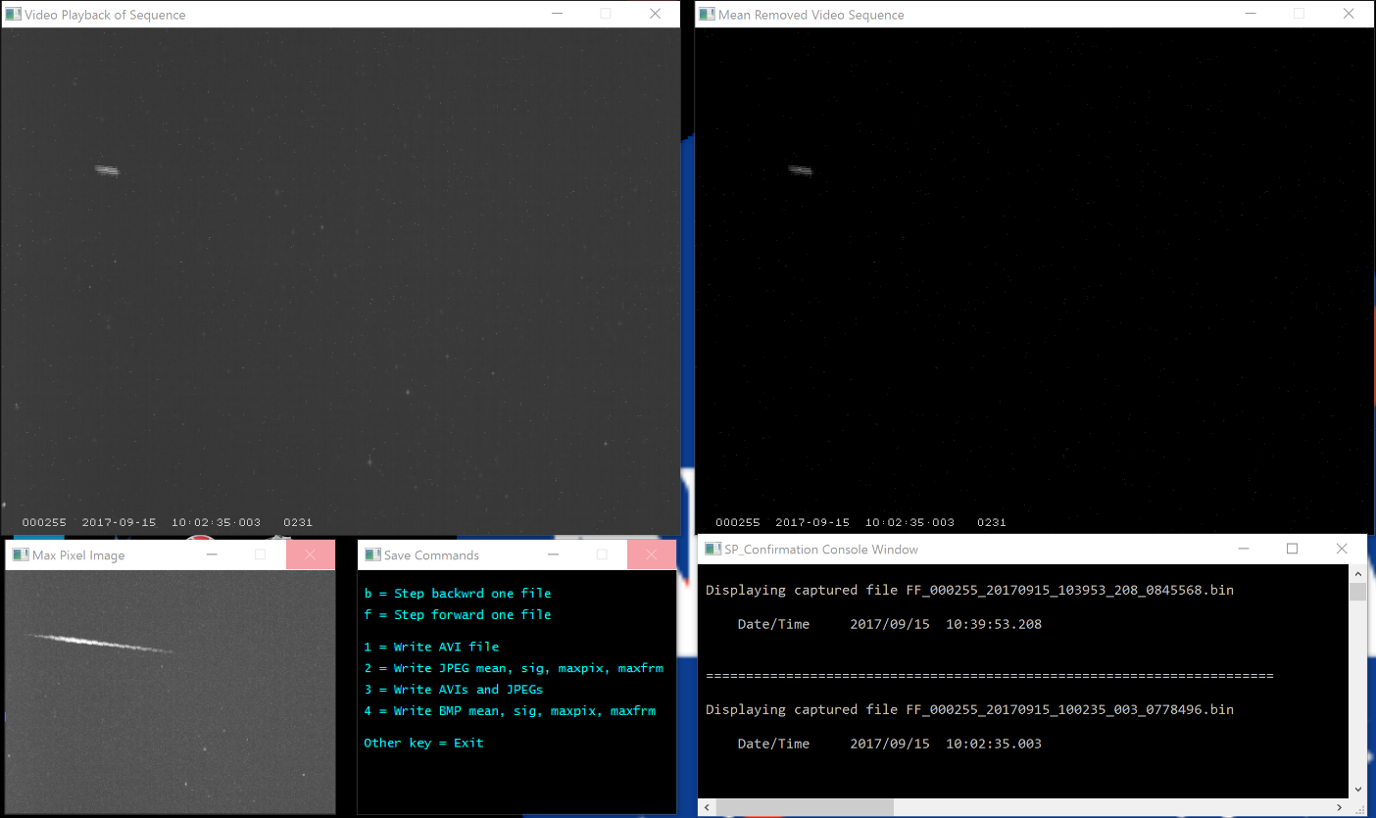
The Video Playback of Sequence window is like a movie of the 8.542 (NTSC) or 10.24 (PAL) seconds of the FF file. Remember, each FF file has 256 individual picture frames at the frame rate defined by the video type. The window has information at the bottom showing (from left to right):
Camera number, date from the FF file name, time from the FF file name, milliseconds from the FF file name, and frame counter. The CAMS date and time represent the starting frame of the FF file.
The Mean Removed Video Sequence window is less useful. I typically minimize this window to make room to move the Max Pixel Image in its place.
Max Pixel Image window is very useful. It shows the max pixel image of the entire 256 frames. Usually, this window is a little brighter than the first window and it will show the track of any moving object in the 256 images of the FF file. As you can see in the example here, there is a small meteor in the middle-right of the image. This helps you know where to look in the Video Playback of Sequence window.
The Save Commands window has the instructions on how to use the program. These commands are only effective if the SP_Confirmation Console window has the keyboard focus. Press “b” to show the previous FF file in the directory. Press “f” to show the next FF file in the directory. For the Save commands, you have 4 choices. For each of the choices, you will answer a follow up question as to how many consecutive FF files to include. For example, if you have a meteor that lasts for 3 seconds and the first part of the meteor appears in one frame for the first second of the meteor and the final 2-seconds of the meteor will appear in the next FF file. So, if you want an AVI video and JPG files for those two FF files, you’d press 3, then enter 2 for the number of sequential files. To exit the SPFF_SingleFileViewer, press the space bar.
The SP_Confirmation Console Window shows which FF file it is showing. It is also the window that needs to have the active focus when entering any of the save commands, including the “f” and “b” commands.
On most CAMS systems, the default program for the BIN type is set to the SPFF_SingleFileViewer.exe program. That allows you to double-click on FF*.bin files to view them. If this is not configured on your system, you can right-click on any FF*.bin file and select “Open With…”. The “How do you want to open this file’ dialog appears. Select the “Always use this App to open “.bin” files checkbox. Select “More Apps”. Scroll the list all the way down until you see, “Look for another app on this PC”. Click that link. The “Open with…” dialog appears. Navigate to and select “?:\cams2_board0\CAMS\SPFF_SingleFileViewer.exe”. Then click Open.

End

